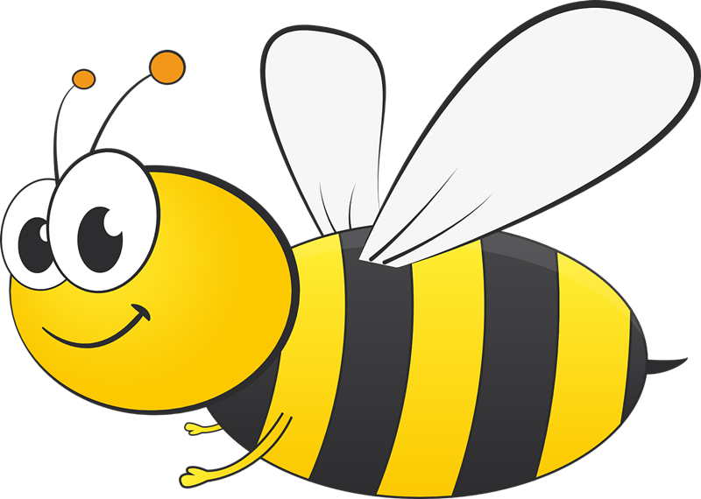

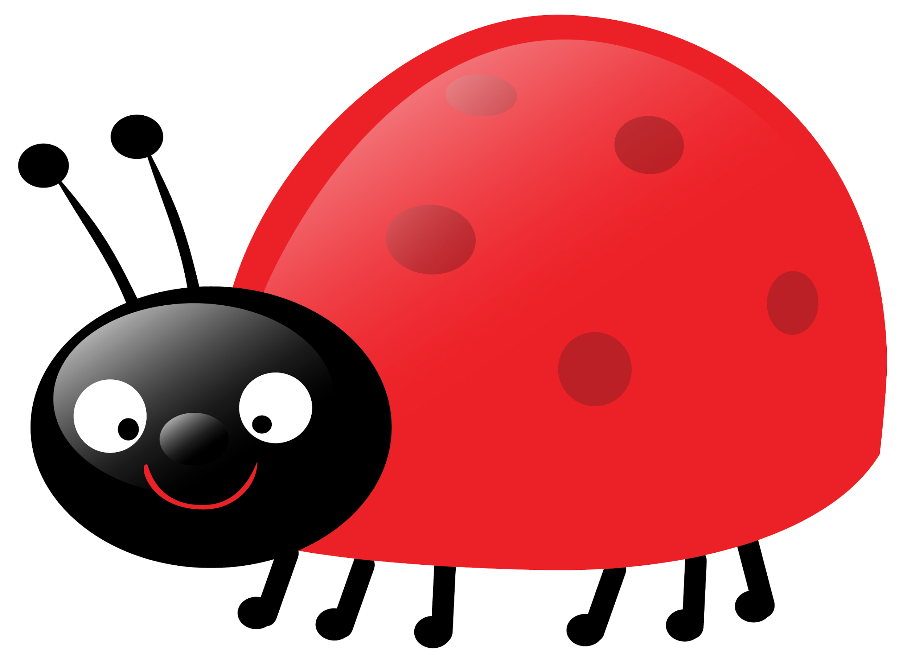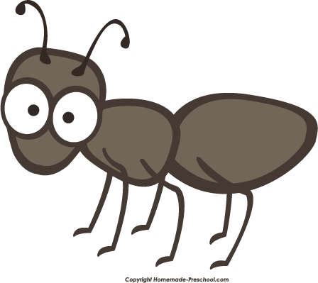

**Insect Unit Plan**

**Grade 1 Language Arts**

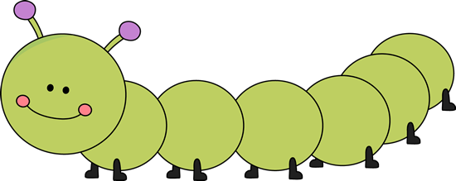**Danika Resch**

***Rationale:*** This language arts unit is specifically designed to assist students in familiarizing themselves with the structure of books and to understand the writing process using many of their own personal experiences. In doing so, students are more open to the writing process as a result of having the choice to relate their writing to things they personally have a connection to in order to make the writing process a more enjoyable experience. This unit highlights a variety of different books including The Very Hungry Caterpillar, The Grouchy Ladybug as well as Hey There Little Ant teaching students how to receive and interpret context cues by examining the cover of theses book and in the same way; how to interpret the content inside when read out loud. In essence, this unit is crucial because students are learning how to transition from simply listening to a story to actually interpreting the story sequencing the events that occur.

***Grade:***

Our unit and both the general as well as the specific outcomes are specifically designed for a Grade 1 class.

***Theme of Unit:***

The theme of our unit is centered around the concept of insects.

***Learner Focus:***

Throughout the entirety of our unit, the goal is for students to relate knowledge learned from reading as well as listening to books being read and translating that into the creation of their own pieces of writing. The big focus is for students to be able to grasp an understanding of the different parts of a story including the beginning, middle and end and then use this knowledge to create their own stories. Through the use of three different books on insects, students will use every part of these books including the context on the outside and inside to assist in comprehending as well as predicting the content. Through asking questions, personal experiences, guest speakers, books on insects as well as shared listening; students will be able to relate this content to their own writing and create stories that are enriched with a beginning, middle and an end. In order for this unit to begin, the teacher first needs to learn about the extent of experiences students have had in the past with reading books as well as their background knowledge with interpreting the covers of books. In addition, the teacher needs to know if students are capable of writing simple sentences in order to build up to writing stories with a beginning, middle as well as an end. Students will become engaged with the content of this unit by relating their own personal experiences to the books as well as their own writing. Not only that, but students will also be engaged by the Kagan strategies used throughout the lessons in addition to the theme of the unit which is insects! Lastly, each student will be expected to show growth and improvement in their writing capabilities and content included in their stories throughout the duration of the unit.

***General Outcomes:***

**2.** Students will listen, speak, read, write, view and represent to comprehend and respond personally and critically to oral, print and other media texts.

**3.** Students will listen, speak, read, write, view and represent to manage ideas and information.

**4.** Students will listen, speak, read, write, view and represent to enhance the clarity and artistry of communication.

***Specific Outcomes:***

***2.1 Use Strategies and Cues***

**Use references**

* use a displayed alphabet as an aid when writing

**Use prior knowledge**

* use knowledge of context, pictures, letters, words, sentences, predictable patterns and rhymes in a variety of oral, print and other media texts to construct and confirm meaning
* use knowledge of print, pictures, book covers and title pages to construct and confirm meaning

**Use prior knowledge**

* use knowledge of how oral language is used in a variety of contexts to construct and confirm meaning
* use previous experience and knowledge of oral language to make connections to the meaning of oral, print and other media texts
* use knowledge of context, pictures, letters, words, sentences, predictable patterns and rhymes in a variety of oral, print and other media texts to construct and confirm meaning
* use knowledge of print, pictures, book covers and title pages to construct and confirm meaning

***2.2 Respond to Texts***

**Experience various texts**

* participate in shared listening, reading and viewing experiences, using oral, print and other media texts from a variety of cultural traditions and genres, such as poems, storytelling by elders, pattern books, audiotapes, stories and cartoons

**Construct meaning from texts**

* relate aspects of stories and characters to personal feelings and experiences

**Use phonics and structural analysis**

* + segment and blend sounds in words spoken or heard
  + use phonic knowledge and skills to read unfamiliar words in context
  + use analogy to generate and read phonetically regular word families
  + associate sounds with letters and some letter clusters

**Construct meaning from texts**

* relate aspects of stories and characters to personal feelings and experiences
* retell interesting or important aspects of oral, print and other media texts
* tell or represent the beginning, middle and end of stories
* tell, represent or write about experiences similar or related to those in oral, print and other media text
* tell what was liked or disliked about oral, print and other media texts

***2.3 Understand forms, elements, and techniques***

**Understand techniques and elements**

* know that stories have beginnings, middles and endings tell what characters do or what happens to them in a variety of oral, print and other media texts

***2.4 Create Original Text***

**Structure texts**

* write, represent and tell brief narratives about own ideas and experiences

**Generate ideas**

* generate and contribute ideas for individual or group oral, print and other media texts

***3.2 Select and Process***

**Use a variety of sources**

* find information on a topic, using a variety of sources, such as picture books, concept books, people and field trips

***4.1 Enhance and Improve***

**Enhance artistry**

* use words and pictures to add sensory detail in oral, print and other media texts
* Appraise own and other's' work

**Appraise own and other's' work**

* make statements related to the content of own and others' pictures, stories or talk

***4.3 Present and Share***

**Present information**

* present ideas and information to a familiar audience, and respond to questions

**Use effective oral and visual communication**

* speak in a clear voice, with appropriate volume, to an audience

**Demonstrate attentive listening and viewing**

* ask questions to clarify information
* be attentive and show interest during listening or viewing activities

***Instructional Strategies:***

Included throughout our unit was the use of a variety of different instructional strategies including *stand up, hand up, pair up, placemat activity, mind mapping in addition to jot thoughts.* We incorporated the use of these instructional strategies for a variety of different reasons including having students create as well as share their ideas and pieces of writing with their peers in addition to get students up and moving with total engagement from the majority of the class at any given time. Generally speaking, we will be incorporating the instructional strategies above throughout the duration of our unit by having students generate ideas from their own selves as well as others and then being able to share and receive feedback from their fellow peers.

***Resources and Materials:***

|  |  |
| --- | --- |
| **Materials:** | **Equipment: Special Events** |
| * Caterpillar alphabets the students made * Recording Worksheet for outside activity * Writing Journals * The book *“The Grouchy Ladybug”* by Eric Carle * Large scale paper * Markers * YouTube video of a reading of *“The Grouchy Ladybug”* * <https://www.youtube.com/watch?v=RFNZvJbzmms> * Ladybug creating worksheet * Each student’s school picture * Scissors * Glue * Sticky notes * KWL Chart * YouTube video all about bees & beekeepers * <https://www.youtube.com/watch?v=qgAibEdrHpg> * Premade book pages with a space for a picture and lines at the bottom for sentences. * Blank pieces of paper for each group * Pencils * Poster reading “Welcome to the Bug Zoo” * Large white board or piece of paper to write on * Student journals * A personal story of your own written on 3 separate pages (separated into the beginning, the middle, and the end) * *Hey, Little Ant* by Philip M. Hoose * Piece of paper for each student * Would You Squish the Ant? Writing sheets * *The Very Hungry Caterpillar* by Eric Carle * Worksheets with the first letter of each noun mentioned in the book replaced with a blank * 108 circles (about as big as your hand) of colored construction paper * Tape * Markers | * Going outside to observe the insects and what else they saw, heard, smelt etc.  Sticky notes * Beekeeper guest speaker comes in to discuss their job and bees to the class. * Multiple containers each filled with a different type of bug that you found outside |

***Differentiating Instruction & Instructional Intelligences & Incorporating Bloom's Taxonomy Questions:***

In order for the students to be able to interact with one another and be able to communicate their knowledge with one another, they must have communication skills. They also must have interpersonal skills, which we build on throughout our unit.

Our lesson plan offers multiple common projects that the students will be engaged in. These include: opinion writing, personal experience writing, mind mapping, creation of a caterpillar alphabet, and worksheets.

To encourage students interaction this lesson plan incorporates Kagan Strategies and Instructional Intelligences. These activities promote 100% engagement for each student.

To extend the tasks in this unit, we are able to add bonus questions to challenge students. To modify the tasks in this unit, we are able to pair up students with a more advanced learner to aid them in their learning. We are also able to supply the students with manipulatives in order to aid in their visual and tactile learning.

We include all of the multiple intelligences in this unit, a couple each lesson, to assure that all students are able to understand the content. We also switch up the assignments to offer the students a wide variety of outlets for their knowledge. These include individual writing, group mind mapping, and placemat activities.

In our unit we keep in mind Bloom’s Taxonomy in order to focus our teaching as well as focus the learner in varying depths.

***Timeline:***

|  |  |  |  |
| --- | --- | --- | --- |
| **Day 1**  * Students walk around the Bug Zoo as an introduction to the unit * Students organize parts of a story as a group to learn about the beginning, middle, and end components of the story | **Day 2**  * Students are read Hey Little Ant * They pair up with various partners and discuss what happened in the beginning, middle, and end of the book * They draw pictures to represent the different parts of the story | **Day 3**  * Students create mind maps based on how the cover of Hey Little Ant relates to the story inside | **Day 4**  * Students write about whether they would have squished the ant in Hey Little Ant |
| **Day 5**  * Students are read The Hungry Caterpillar * Discussion of letter sounds that were noticed in the book * Students work on handout based on letter sounds found in the hungry caterpillar | **Day 6**  * Students work in groups to create their own alphabet based on The Hungry Caterpillar book | **Day 7**  * Go outside on a nature walk and look for insects. * Come inside and write in journals about what they saw, heard, smelled, etc * Use alphabets made the day before to assist in writing and spelling words. | **Day 8**  * Read “The Grouchy Ladybug” book by Eric Carle. * Students will perform a placemat activity about ideas that make them grouchy. * Students will then choose one of their ideas and write a personal story about what makes them grouchy. |
| **Day 9** Perform a mini-lesson on. speech bubblesStand Up, Hand Up, Pair Up activity where children read their stories from the previous lesson.Students will then take what makes them grouchy and use it to complete the sentence “I am grouchy because…” putting it in a speech bubble.Students will construct a ladybug with their writing from the previous lesson and their speech bubble. | **Day 10**  * KWL chart where students write what they know about bees/beekeepers, what they want to know, and what they’ve learned. * Beekeeper guest speaker comes into the class to talk about their job as well as bees. * Students use their questions they’ve created to ask the beekeeper. | **Day 11**  * Students create a class insect book! * Students select their favourite insect learned about from the unit to write their page on. * Students write about the insect and include an illustration at the top of the page. * Stand Up, Hand Up, Pair Up to show and describe work to peers. | **Day 12**Read-aloud of class book created in the previous lesson.In groups, students choose an insect and create “A Day in the Life” skit.The class asks the group performing their skit questions in order to try and guess which insect they were interpreting. |

***Remediation and Extension:***

If this unit finishes more quickly than anticipated, we have a couple ideas in mind. The students will have the opportunity to peer edit the written work that they completed in this unit. This will allow students to gain ideas from their peers as well as improve their own work. The outcome covered in this would be 3.4 Share and Review: Share ideas and information,share ideas and information from oral, print and other media texts with familiar audiences.

We could also build on this unit by including another book such as Hello Bugs by Smriti Prasadam. This book would complement the bee speaker that we have in our unit as well as give us the opportunity to offer more activities for the students to work on.

***Assessment and Evaluation:***

Throughout the unit we utilize formative and summative assessment to see where out students knowledge is it. For summative assessment throughout the unit, we will make teacher observations as well as take notes on these observations. We will also have the students us the Traffic Lights assessment to self assess during lessons to check for understanding. For formative assessment throughout the unit, we will use journal entries for students to reflect on their learning. In these journals we will incorporate Three Time Summarization. To assess at the end of the unit we would use a Socrative short answer quiz. We believe that this would be the best way to asses the students knowledge because we include a variety of specific outcomes throughout the unit. Students will enjoy this assessment because they are able to complete it on a computer or Ipad, making it feel as though it isn’t really a quiz at all. The short answer aspect enables students to showcase their understanding opposed to a multiple choice test where they can simply guess the correct answer. To assess this short answer quiz, we would have a rubric that details the different types of short answers that their could be.