Art Project Plan

EDUC 4104

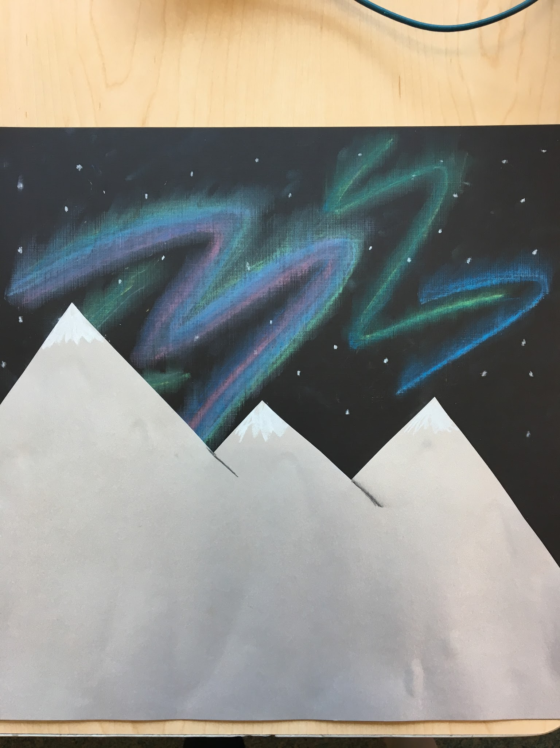

General Description:

|  |  |  |
| --- | --- | --- |
| Theme of Project | Northern Lights | 6 - Creating  5 - Evaluating  4 - Analyzing  3 - Applying  2 - Understanding  1- Remembering |
| Media | Oil and chalk pastels - Primary colors and white  Construction - Black and white | 1 - Remembering (recalling)  2 - Understanding (classifying)  3 - Applying (recreate) |
| Key Art Concepts | Color - 3 Primaries and secondary hues  Hue and Value  Lines, Shapes, and Forms | 1 - Remembering (repeating, recalling)  2 - Understanding (classifying)  3 - Applying (using, illustrating) |
| Grade | One |  |
| Connections | Science: Creating Color | 5 - Evaluating (judging, evaluating)  4 - Analyzing (testing, experimenting, contrasting)  3 - Applying (demonstrating) |
| Duration | Five days - 45 minutes |  |
| Scope of the Whole Unit      IMG_0727.JPG | **Episode One:**  To introduce the art project to the students, the teacher will show a video (<https://www.youtube.com/watch?v=nHn5OO1t1yc>) on the Northern Lights to the students. As the video plays, the teacher will have students come up to the board and draw the lines that they see in the Northern Lights and the landscape in the video. The students will then begin their test booklet. They will practice different lines that they will use to create their own Northern Lights and their landscape. Each different line will be drawn on a different index card, which will be added to the student's test booklet. The test booklet will be used for the students to relate back to when creating their art project.  **Episode Two:**  Students and teachers will have a discussion on primary colours. This will be a recap for students because they will have already learned about primary colors in science. We will talk about combining these colors and the secondary colors that are created. Students will then be asked what colors they remember being in the Northern Lights. In their test booklets, students will use pastels to combine primary colors to create the secondary colors that they want to use in their Northern Lights.  **Episode Three:**  Demonstration to students between solid line and smudged line (using pastel). Students will come to the understanding that smudged lines look more realistic when recreating the Northern Lights. Students will use their test booklet to try different smudging techniques. They will try using their finger, a cotton ball, a q-tip, and a sponge to smudge their pastels. The students will find their prefered technique or techniques for smudging their pastels to use for their art project.  **Episode Four:**  Students will use think-pair-share to discuss with their peers what lines, landscape, smudging techniques, and color combinations that they will be using to create their Northern Lights. Students will refer to their test booklets. They will tell their peers what option they are using and why. Students will begin their art projects.  **Episode Five:**  Students will complete their Northern Lights art projects.  **Episode Six:**  Using critical friends, students will comment on their peers art projects. Students will then use the feedback from critical friends to edit their art work if they choose to.  **Episode Seven:**  Students will complete the assessment on their Northern Lights art project. | 6 - Creating (developing, constructing)  5 - Evaluating (judging, evaluating)  4 - Analyzing (experimenting, testing, examining)  3 - Applying (illustrating, demonstrating)  2 - Understanding (translating)  1 - Remembering (recalling, reproducing)  IMG_0728.JPG |

Art Objectives:

|  |  |  |
| --- | --- | --- |
| Art Production | Introducing line and smudging alongside previous knowledge of primary color mixing and landscape. | Remembering (recalling, repeating)  Understanding (examining, classifying)  Applying (sketching, using, demonstrating) |
| Art Formalism/Fundamentals | *Line*  *The path of a moving point, that is, a mark made by a tool or instrument as it is drawn across a surface. A line is usually made visible by the fact that it contrasts in value with the surface on which it is drawn.*  *Measure - length and width.*  *Type - straight, curved, angular, zigzag*  *Direction - horizontal, vertical, diagonal*  *Character - quality describes ‘personality’ of line. Can be determined by*  *media and technique.*  *Colour*  *The property of light reflected off the surface in the form of a particular wavelength and perceived as a hue in the spectrum; that is red, orange, yellow, green blue, indigo and violet. Colour is described with three qualities, hue, intensity, and value.*  *Primary Colours*  *The foundation hues from which all other hues are derived: colours that cannot be produced by the mixing of two or more pigments together. In painting , the primaries are red, yellow, and blue.*  *Secondary Colours*  *Colours created by mixing together two primary colours.* | Remembering (memorizing, listing)  Understanding (classifying)  Applying (using, demonstrating) |
| Art History | At the beginning of the unit students are shown a video that includes paintings and drawings of the Northern Lights that have been drawn from different eras. The students will use these images as inspiration as well as for knowledge of the lines and colors that are present in the Northern Lights | Applying (illustrating)  Analyzing (examining, testing)  Evaluating (evaluating) |
| Aesthetics | Students will be able to appreciate the different lines that the artist’s use and be able to relate them to the entire work of art.  Students will be able to understand the different use of color by each artist and apply this information to their own art projects. | Applying (using)  Analyzing (comparing, contrasting, experimenting)  Creating (designing, developing, producing) |
| Art Curriculum Objectives  “I Can” Statements | Component 3 Appreciation:  Students will assess the use of function of objects   * D: Color variation is built on three basic colors * E: Tints and shades of colors or hues affect the contrast of a composition   *I can create secondary colors from primary colors*  *I can see that tints and shades of colors and hues effect the contrast of my artwork*  Component 4 Main Forms and Proportions:  Students will learn the shapes of things as well as develop decorative styles   * E: A horizontal line can be used to divide a picture plane into interesting and varied proportions of sky and ground   *I can use a horizontal line to divide the plan of my picture into different proportions of sky and ground.*  Component 7 Emphasis:  Students will create emphasis based on personal choices   * C: Contrast subject matter with the ground for emphasis   *I can use contrast between the ground and the sky to create emphasis.*  Component 10: Media and Techniques  Students will use media and techniques, with an emphasis on exploration and direct methods in drawing, painting, printmaking, sculpture, fabric arts, photography, and technographic arts   * A: Use a variety of drawing media in an exploratory way to see how each one has its own characteristics   *I can experiment with different drawing materials to see how they look different* |  |

Developmental Objectives:

|  |  |  |
| --- | --- | --- |
| Physical | I can manipulate different tools to blend colors | Remembering (recalling)  Applying (illustrating, demonstrating) |
| Cognitive | I can understand which primary colors create specific secondary colors | Applying (demonstrating)  Analyzing (comparing)  Evaluating (defending) |
| Language | I can use the correct art terminology when creating my artwork | Remembering (memorizing, recalling)  Understanding (explaining, describing)  Applying (demonstrating) |

Social Objectives:

|  |  |  |
| --- | --- | --- |
| Respecting Ideas of Others | *I can listen carefully*  *I can accept feedback from my critical friends* | Applying (demonstrating)  Analyzing (examining, discovering)  Evaluating (defending, appraising) |
| Sharing | *I can share my feedback on my peers artwork through critical friends*  *I can share techniques with others* | Remembering (copying, reproducing)  Understanding (discussing, explaining)  Applying (modifying, using) |
| Contributing to a Group Process | *I can work well with others in a group*  *I contribute my ideas in a group* | Remembering (reproducing)  Understanding (discussing, explaining, describing)  Applying (using)  Analyzing (questioning, examining)  Evaluating (defending, judging) |
| Responsibility | *I can be responsible with my art supplies*  *I can clean up after myself*  *I can listen to art instructions* |  |

Cross-Curricular Objectives:

|  |  |  |
| --- | --- | --- |
| Science General Learner Expectation:  1-5 Identify and evaluate methods for creating colour and for applying colours to different materials. | Science Specific Learner Expectations:   1. Distinguish colours that are transparent from those that are not.   *I can tell the difference between a color I can see through and a color that I can not.*  *I can use different tools or techniques to make a color transparent.*   1. Identify colours in a variety of natural and manufactured objects.   *I can name the colors I see in my environment.* | Bloom’s Taxonomy:  5 - Evaluating (judging, evaluating)  4 - Analyzing (testing, experimenting, contrasting)  3 - Applying (demonstrating) |

Materials:

|  |  |  |  |  |
| --- | --- | --- | --- | --- |
| Art Materials | Art Tools | Pre-Production Supplies | Clean Up Supplies | Changes to the Physical Environment |
| -black and blue construction paper  -white cardstock  -chalk and oil pastels (primaries and white)  -pencils  -white glue  -metal rings  -index cards | -sponges  -paint brushes  -scissors  -q tips | -index cards | -baby wipes  -paper towels | -students will work in their desk groups of four  -clear off desk for art |

|  |  |
| --- | --- |
| Set Up Plan | Clean Up Plan |
| Who:   * Supplies will be laid out ready for use prior to start of all lessons. * Pod member 1 will be in charge of gathering the supplies for their group * Each day it will then rotate through pod members (i.e. day 2 = pod member 2). | Who:   * As a group pod they will be responsible for all cleaning up of their groups area and tools used. * If tools need to be taken back, pod member 2 will be in charge of that. * Each day it will then rotate through pod members (i.e. day 2 = pod member 3). |
| What:   * All supplies necessary for that day's work (supplies, tools, paper, pastels, etc). | What:   * All supplies necessary for that day's work (supplies, tools, paper, pastels, etc). * Cleaning up floor and desks in area of work (i.e. wash off any markings made on tables). |
| When:   * On teachers saying (usually around after introduction to lesson and work time begins). | When:   * On teachers saying (with a fair amount of time left to give ample time and a proper clean up) |
| Where:   * In the classroom. | Where:   * In the classroom. |
| Why:   * To avoid chaos and unnecessary confusion or students walking around avoiding work time. | Why:   * Respecting the classroom, tools, and workspaces of others around you. |

Pre-production Activity:

Students will create a test booklet where they will experiment with line, mixing primary colors, landscapes, and smudging techniques.

Visual Production:

Watch video on the Northern Lights

Art Production:

|  |
| --- |
| Episode One:  To introduce the art project to the students, the teacher will show a video on the Northern Lights to the students. As the video plays, the teacher will have students come up to the board and draw the lines that they see in the Northern Lights in the video. We will discuss all of the lines present including horizontal, vertical, and diagonal. The students will then begin their test booklet. They will practice different lines that they will use to create their own Northern Lights. Each different line will be drawn on a different index card, which will be added to the student's test booklet. The test booklet will be used for the students to relate back to when creating their art project.  Episode Two:  Students and teachers will have a discussion on primary colours. This will be a recap for students because they will have already learned about primary colors in science. We will talk about combining these colors and the secondary colors that are created. Students will then be asked what colors they remember being in the Northern Lights. In their test booklets, students will use pastels to combine primary colors to create the secondary colors that they want to use in their Northern Lights.  Episode Three:  Demonstration to students between solid line and smudged line (using pastel). Students will come to the understanding that smudged lines look more realistic when recreating the Northern Lights. Students will use their test booklet to try different smudging techniques. They will try using their finger, a cotton ball, a q-tip, and a sponge to smudge their pastels. The students will find their prefered technique or techniques for smudging their pastels to use for their art project.  Episode Four:  Students will use think-pair-share to discuss with their peers what lines, landscape, smudging techniques, and color combinations that they will be using to create their Northern Lights. Students will refer to their test booklets. They will tell their peers what option they are using and why. Students will begin their art projects.  Episode Five:  Students will complete their Northern Lights art projects.  Episode Six:  Using critical friends, students will comment on their peers art projects. Students will then use the feedback from critical friends to edit their art work if they choose to.  Episode Seven:  Students will complete the assessment on their Northern Lights art project. |

Assessment:

Attached

Critical Friends:

Suggestion - Our critical friends group suggested that we adapt our final assessment language to 6 year olds.

Alterations: We created an assessment that would be easier for grade 6 students to demonstrate their knowledge. Instead of offering questions as an assessment, the students fill out a small worksheet where they demonstrate what techniques that they used.

Suggestion - Our critical friends suggested that we take out some of our art objectives because they felt that the amount that we had would be overwhelming for grade one students.

Alterations: We decided to take out three objectives that we had so that we can focus more on the remaining objectives while keeping it more simple for grade one students.

Suggestion: Our critical friends suggested placing visual examples in our art lesson plan.

Alterations: We added some pictures to further demonstrate how the unit would look.

Rubric:

|  |  |  |  |
| --- | --- | --- | --- |
| DIMENSIONS | EXEMPLARY | COMPETENT | BEGINNING |
| I can make an in depth  classroom ready art  unit plan. | All area’s in the art plan were complete, clear and classroom ready. | Most area’s in the art plan were complete. Some areas were not completely clear and a few things need to be changed to be classroom ready | Very little details were included in art plan and this is not ready for the classroom. |
| I can develop one episode found in art unit and present it to my peers. | The lesson plan was complete. Students (peers) were engaged and interested in the project | The lesson plan was mostly complete some area’s needed work. Students (peers) were some what engaged. | Lesson plan was not planned out carefully.  Students were not engaged in the lesson at all. |
| I can demonstrate my understanding of Blooms both in the lesson plan and in the presentation | Blooms verbs were used correctly and in a way to provide deeper thinking to student both in lesson plan and in presentation | Blooms verbs were used but didn’t connect with I can statements all the time. Some were used in the presentation | Little attention was given to the use of Blooms verbs both in the lesson plan and presentation. |
| I can connect art to other curricular subject enhancing students learning and have used other provinces Program of Studies for Clarification and enrichment of art curriculum. | Art lessons were enriched by using other curriculum subject area’s in planning. Also art curriculum was enhanced by looking other provinces Program of Studies. | Some connections were made to other subject area and some mention of other provinces program of studies. | No effort was made to connect unit to other curricular subjects or other provinces art program of studies. |
| I can use many different assessments to help students grow and become more self aware of art produced. | More than one assessment strategies was used and rich discussion had as student, classmates and teacher discussed works of art. | One strategies was used to discuss artwork created. Not a lot of time was spent in reflection and enrichment activities. | Little or no assessment or reflection used to enrich art activities |

Reflection:

We feel as though this art project will be successful inside a grade one classroom. We believe that using the test booklet allows students to test out different options before applying them to their final project so the final product is customized based on the choices of the students. We had Megan’s daughter, a grade one student, complete the prototype for us and it went incredibly well. She enjoyed the project and her final project was incredibly successful.

References

Alberta Learning. (1985). Art. Retrieved from: http://www.education.alberta.ca/media/312998

/elemart.pdf

Alberta Learning. (1996). Science. Retrieved from: http://www.learnalberta.ca/ProgramOfStudy.aspx?ProgramId=379983#