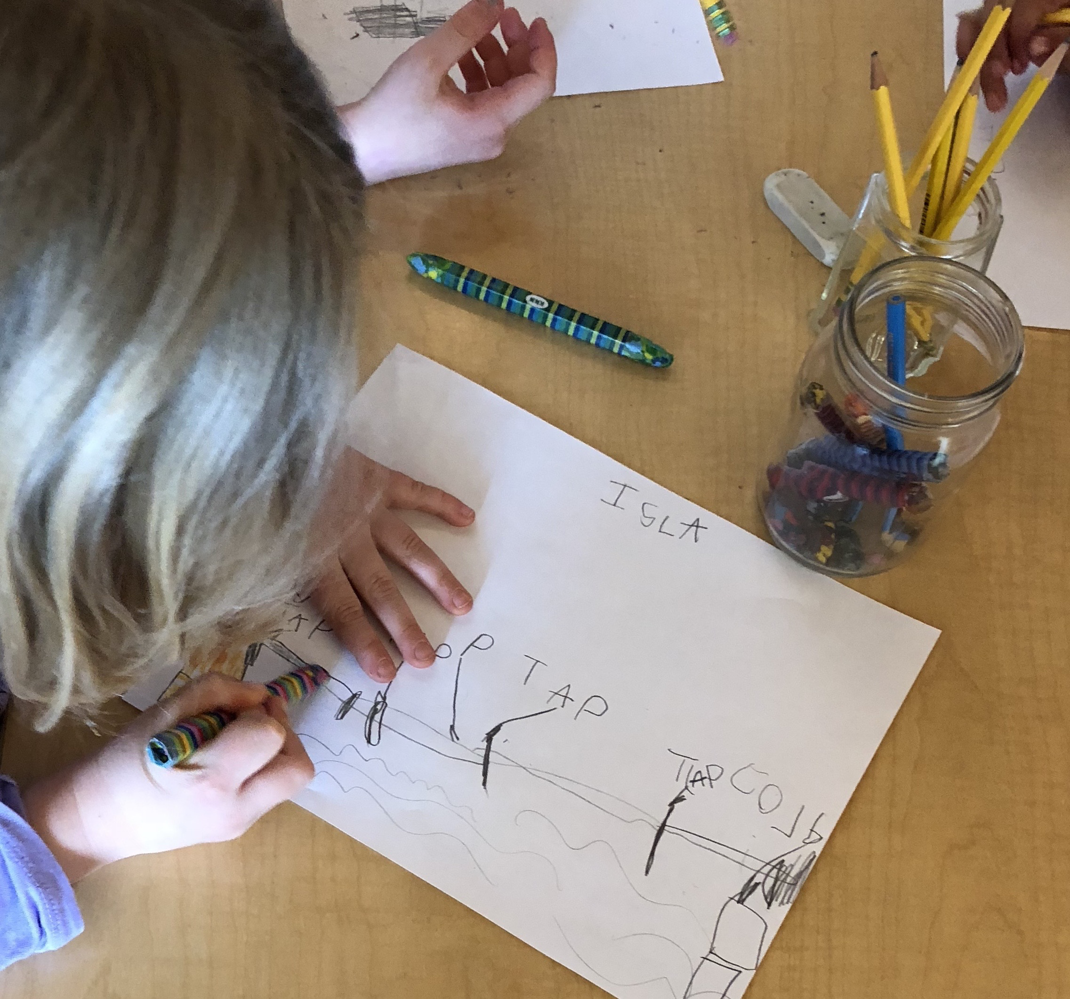
The Three Billy Goats Gruff

We then faced the challenge of building the bridge for the three billy goats!
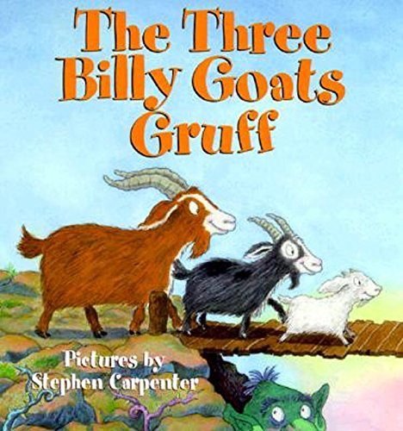

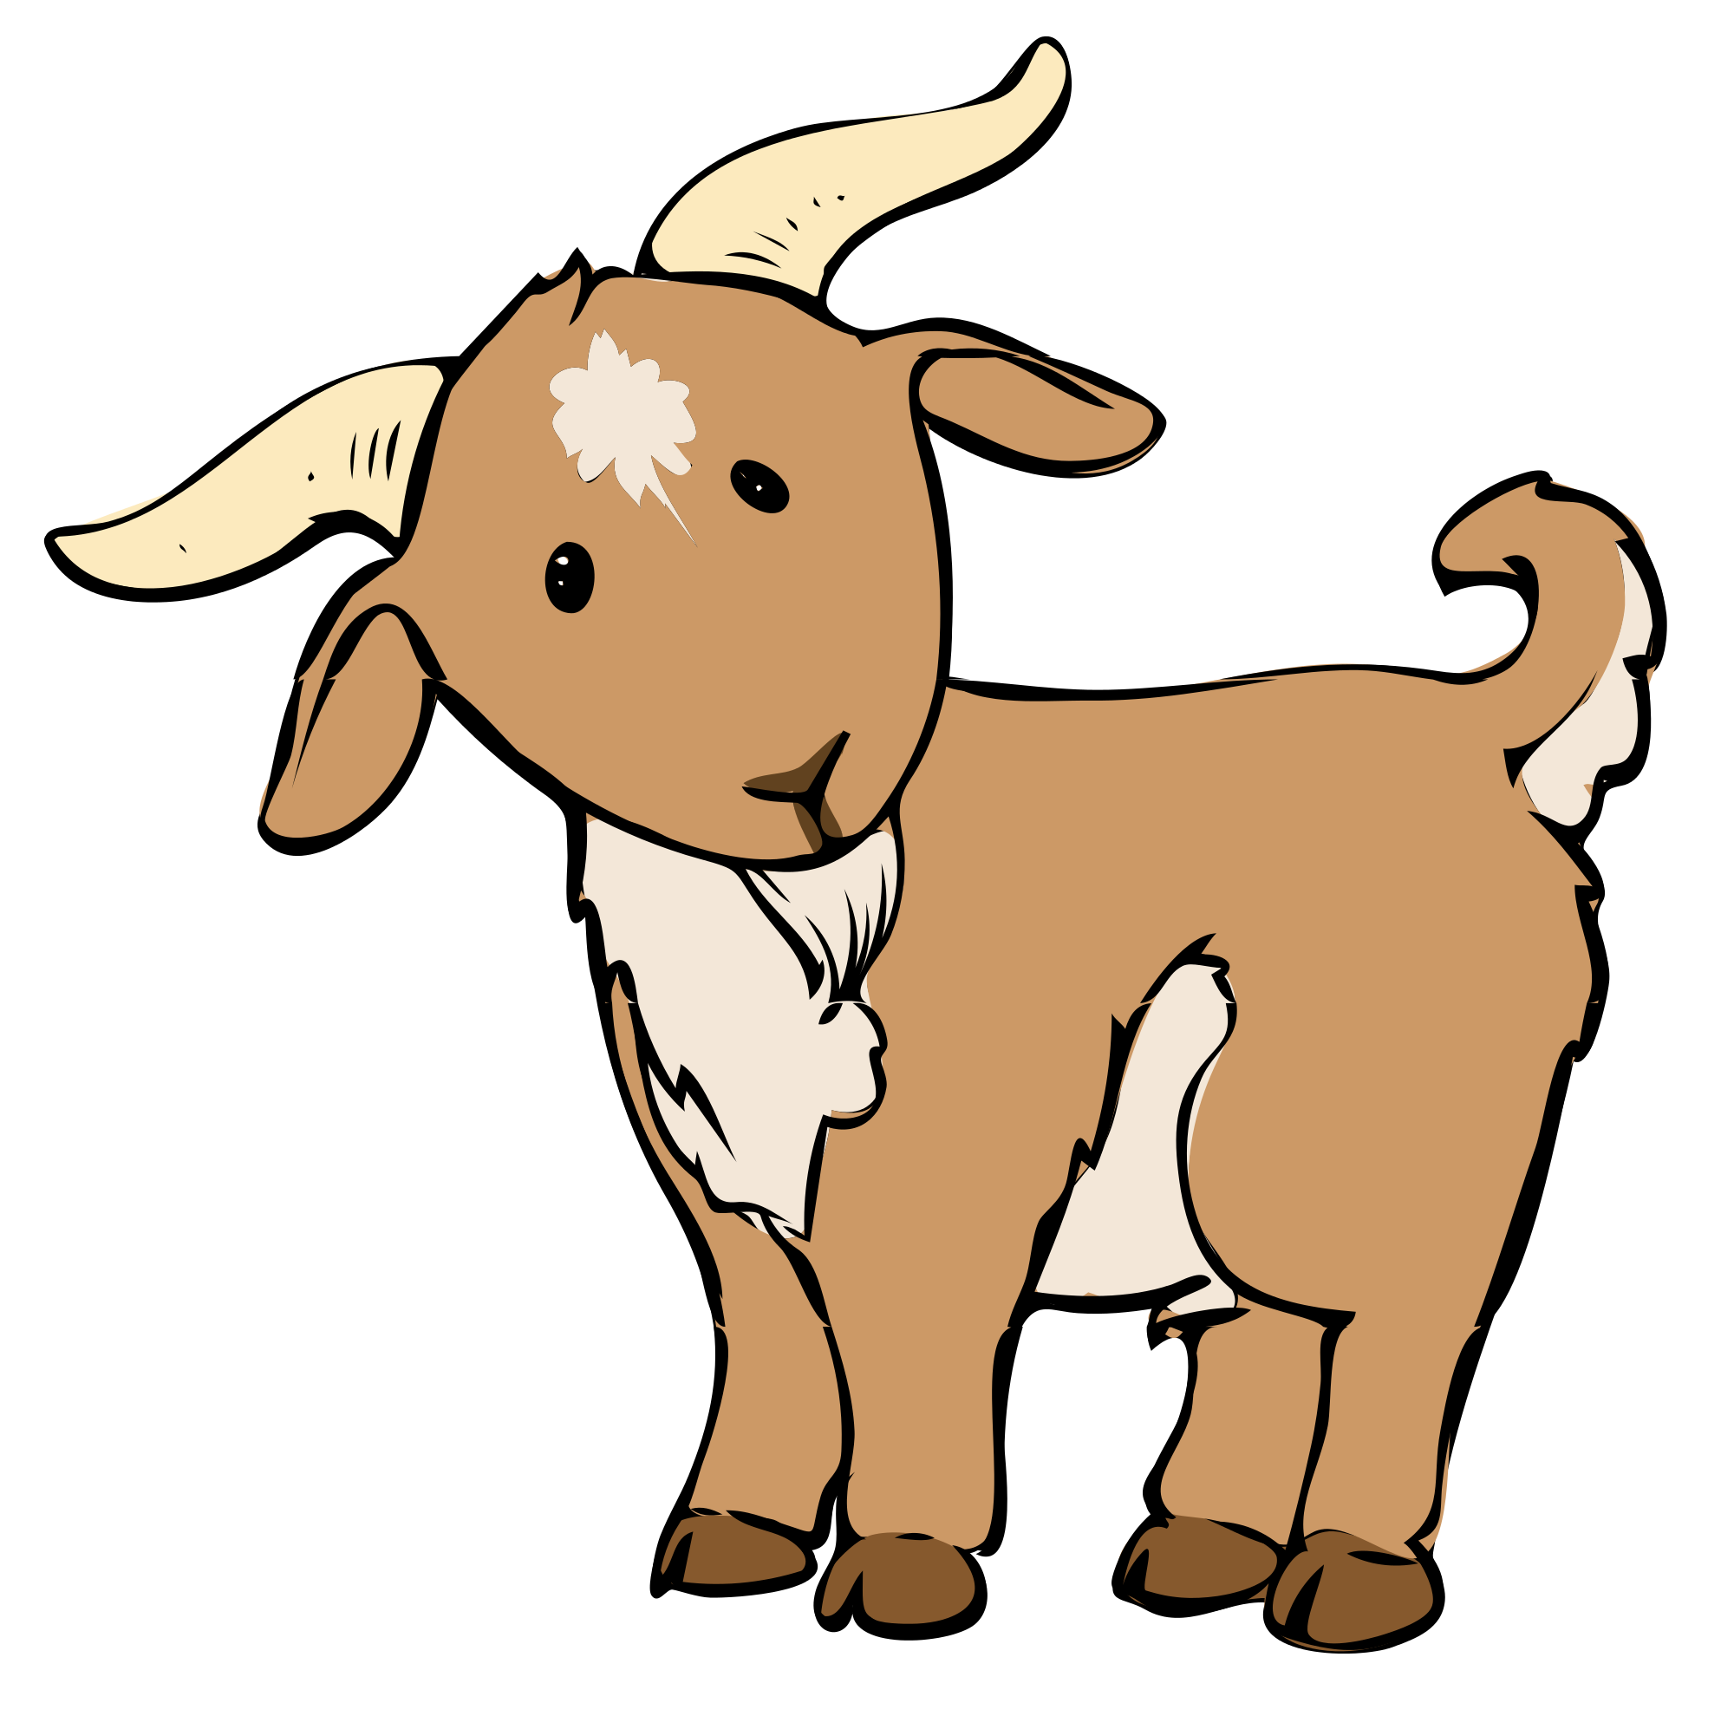
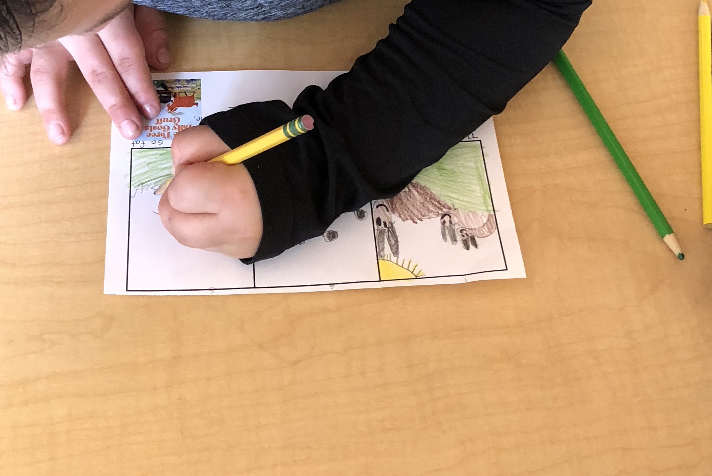
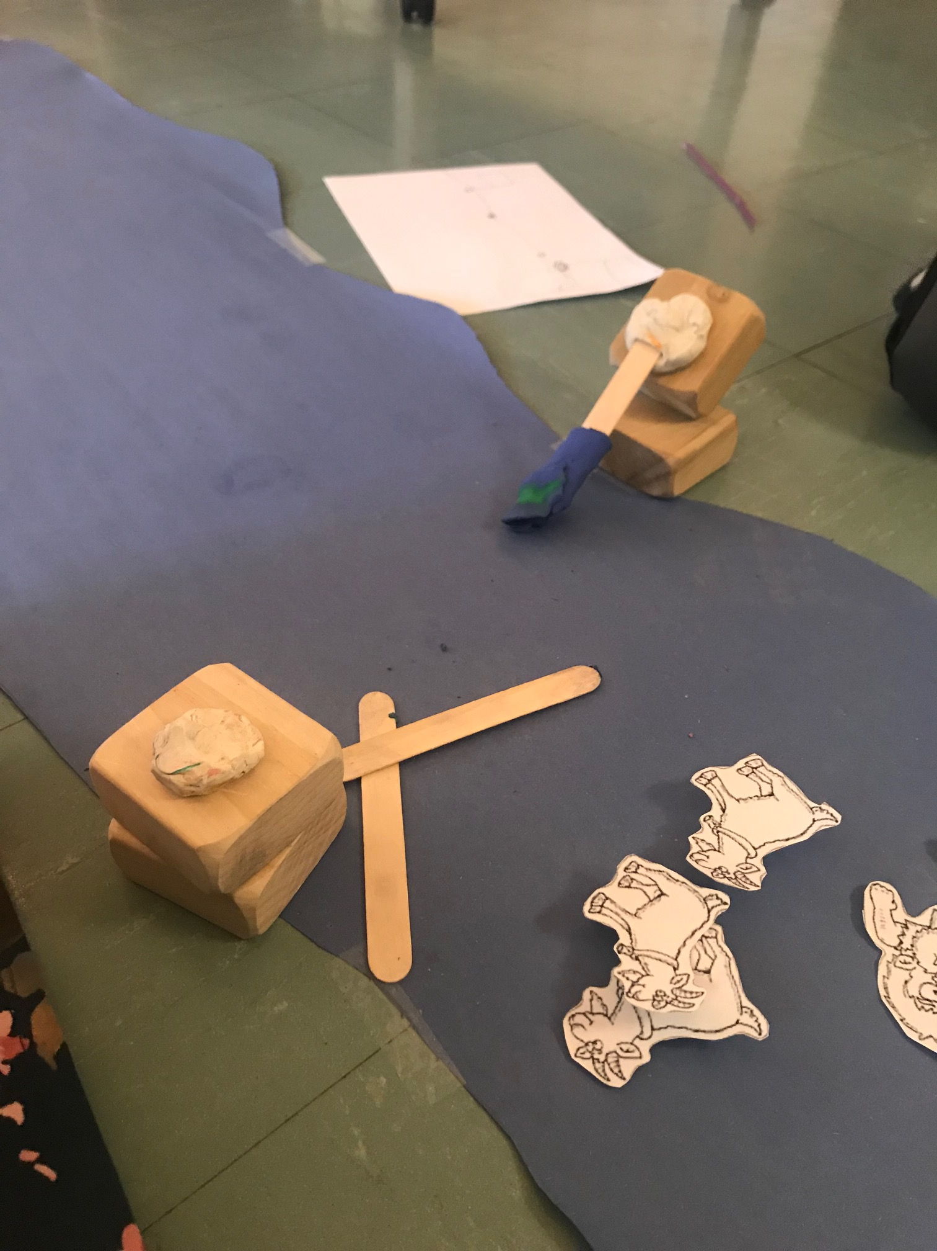
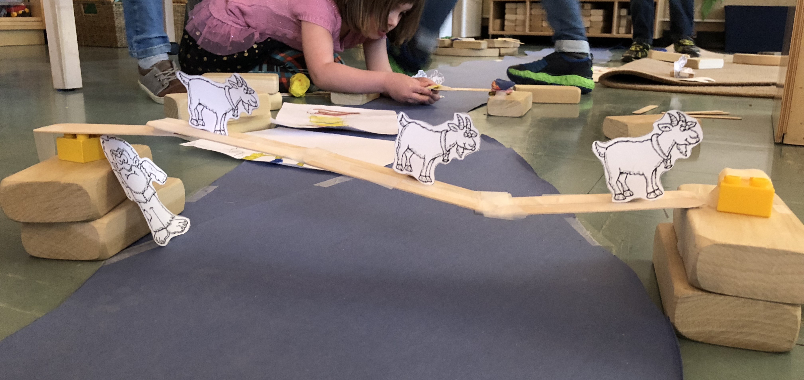
We planned our bridges by creating diagrams. We then collaborated with a friend and built our bridge together! We learned that we had to edit some of our designs so that our bridges could support our billy goats crossing the river. In the end, all of the billy goats were safe!
Love, Miss Resch
We read The Three Billy Goats Gruff then drew pictures of what we thought happened at the beginning, middle, and end of the story.

