**Introduction**

The unit that I am teaching is Exploring Liquids at the grade two level. This is an important unit for students to learn because it delves into knowledge that the students need to understand to further develop as scientists. The main concept that students will study is liquids, which surrounds them in different ways every day. We will also delve into the states of matter enabling the students to apply their newfound knowledge to things that they see and do. We will also discuss multiple specific outcomes in the grade two math curriculum. This will give students the knowledge that math is not only used in math class, but in scientific situations and in real life.

**Learner Focus**

In the unit, Exploring Liquids, students will learn about liquids, how they interact with each other, and how they react with other materials. Using math, social studies, and language arts they will apply this knowledge about liquids to the world and it’s problems.

To begin this unit the students’ prerequisite knowledge of liquids and water must be known. Therefore, in the first unit the students will be asked to write about their knowledge in these areas and discuss it with classmates.

**General Outcomes**

Science

* Outcome 2-5
  + Describe some properties of water and other liquids, and recognize the importance of water to living and nonliving things
* Outcome 2-6
  + Describe the interaction of water with different materials, and apply that knowledge to practical problems of drying, liquid absorption and liquid containment

Math

* Develop Number Sense
* Patterns & Relations
  + Use patterns to describe the world and to solve problems
* Patterns & Relations
  + Represent algebraic expressions in multiple ways
* Shape & Space
  + Use direct and indirect measurements to solve problems
* Data Analysis
  + Collect, display, and analyze data to solve problems

Language Arts

* Outcome 1
  + Students will listen, speak, read, write, view and represent to explore thoughts, ideas, feelings and experiences.
* Outcome 2
  + Students will listen, speak, read, write, view and represent to comprehend and respond personally and critically to oral, print and other media texts

Social Studies

* Outcome 2.1
* Students will demonstrate an understanding and appreciation of how geography, culture, language, heritage, economics, and resources shape and change Canada’s communities

Physical Education

* Students will acquire skills through a variety of developmentally appropriate movement activities; dance, games, types of gymnastics, individual activities and activities in an alternative environment; e.g., aquatics and outdoor pursuits.

**Specific Outcomes**

Science

* Recognize and describe characteristics of liquids
  + Recognize and describe liquid flow
  + Describe the shape of drops
  + Describe the surface of calm water
* Recognize that water is a component of many materials and of living things
* Compare the amount of liquid absorbed by different materials
* Evaluate the suitability of different materials for containing liquids. Students should recognize that that materials such as writing paper and unglazed pottery are not waterproof and would not be suitable as containers; but that waxed paper and glazed pottery are waterproof and could be used in constructing or lining a liquid container
* Compare water with one or more other liquid, such as cooking oil, glycerin, or water mixed with liquid detergent. Comparisons may be based on characteristics, such as colour, ease of flow, tendency of drops to form a ball shape, interactions with other liquids and interactions with solid materials
* Demonstrate and understanding that liquid water can be changed to other states
  + recognize that on cooling, liquid water freezes into ice and that on heating, it melts back into liquid water with properties the same as before
  + recognize that on heating, liquid water may be changed into steam or water vapor and that this change can be reversed on cooling
  + identify examples in which water is changed from one form to another.
* Recognize human responsibilities for maintaining clean supplies of water, and identify actions that are taken to ensure that water supplies are safe.
* Recognize human responsibilities for maintaining clean supplies of water, and identify actions that are taken to ensure that water supplies are safe.

Math

* Describe the order or relative position, using ordinal numbers
* Describe the meaning of equality and inequality, concretely and pictorially
* Record equalities and inequalities symbolically, using the equal symbol or the not equal symbol
* Measure length to the nearest nonstandard unit
* Gather and record data to answer questions
* Apply mental mathematics strategies for basic addition facts and related subtraction facts to 18

Language Arts

* Discover and Explore 1.1
  + Talk about how new ideas and information have changed previous understanding
* Respond to Texts 2.2
  + Construct meaning from texts
  + Express thoughts or feelings related to the events in oral, print, and other media texts
* Understand forms, elements, and techniques 2.3
  + Understand forms and genres
  + Recognize that ideas and information can be expressed in a variety of oral, print, and other media texts

Social Studies

* 2.1.1
* Demonstrate care and concern for the environment

Physical Education

* A2-1
* Select and preform locomotor skills involved in a variety of activities

**Process Outcomes**

To begin the unit I started with recognizing and describing the characteristics of water. I used this outcome to find the students pre-requisite knowledge on the main concepts of the unit and then built on the knowledge that they already had. In the next lesson we discuss water and what it is a component of. I placed this lesson second because the students can add to their understanding of water by understanding what needs it to survive. Sorting was included in this lesson to allow students to differentiate between things that need water and things that do not. In the next lesson we continue on with the same scientific concept in order to get across the importance of water to students. The mathematical concepts of equal and not equal are included in this lesson to complement the concept of how much water there is on earth. In the next lesson students learn how to measure different items using nonstandard units. Measurement is in this part of the unit because students need to learn this before they start measuring fluids using the lines on beakers in the next lessons. Next, the students go on a field trip to further explore water. Measurement is incorporated here because students can use their newfound knowledge of measurement to pour and measure the liquids they are examining. The next lesson consists of exploring different types of liquids. I thought that this was a good way to take the unit because students would feel very confident with their knowledge of water at this point and could apply it to other types of liquids. In order to examine these liquids the students gather and record the data that they find. In the next unit the states of matter are introduced to the students. I thought that this would be a good concept to continue with because the students have just learned about liquids, one part of the states of matter. The next lesson is a jello experiment. In this experiment the students work with the teacher to create jello, learning about how the states of matter also occur in our food. Also in this lesson, the students are asked to write a journal entry regarding their understanding of the unit concepts so far. I placed this inquiry day in the middle of the unit so I could alter any following lessons to incorporate concepts that the students feel that they do not fully understand yet. The next lesson builds off of the concept of the states of matter. Since this is a harder idea to understand and has multiple parts, I felt as though it should be examined more in depth. This lesson allows students to apply the states of matter to the real world. The students learn about the water cycle and use relative position to organize their water cycle recreations. The last concept taught in this unit is human responsibility for taking care of the environment. I think this is the best place for this lesson because students now understand different water and liquids and can understand water pollution more easily. This is covered in lessons 10, 11 and 13. In lesson 10 the students are simply taught about what water pollution is and shown some examples. Language Arts and Social Studies are both added to lesson 10 because students are reacting to how they feel about a book on pollution and are caring about the environment. In the next lesson students begin on their presentations, applying their knowledge of water pollution. The students then present their presentations in lesson 13 and use mental math to add up the marks that they received using their rubrics. In both of these lessons, Language Arts in incorporated to demonstrate to students that they can present information in a multitude of ways. In lesson 12 there is a test on all of the concepts taught in this unit. The test was placed in the second last unit so that we could go over the mistakes that the students made and allow them to ask any questions they may have on the unit concepts after their presentations the next lesson.

**3 E’s, Kagan, etc.**

Throughout this unit I incorporate at least one “Educated Albertan” outcome in each unit. Students will become globally aware of water, becoming entrepreneurial. They will utilize communication skills, becoming engaged. They will also think critically, becoming more ethical. I think that these traits are important because they help students gain skills that help them become better citizens.

In each lesson within this unit at least one Kagan Strategy or Instructional Intelligence are used. These include techniques that allow me to check for understanding, such as Thumbs Up, Thumbs Down with students eyes closed. I also include strategies that allow students to think in groups, like mind mapping. These strategies are important to include because they promote cooperation and engagement.

Each one of the Multiple Intelligences are included in some way throughout this unit. For example, interpersonal inclined students will excel when the students work in groups and bodily-kinesthetic inclined students will excel when they build their own water cycles using pictures. Covering all of these intelligences is incredibly important throughout the unit so each student can understand the material, no matter how they learn.

Bloom’s Questions are included in this unit with at least one per lesson. An example of this question is, recall the water cycle and recreate it. These questions are important so that you can focus what the students are learning and how deeply they are thinking.

**Resources and Materials**

* “I Can” statement sheet for each student
* Scribblers for journals
* Cut out pictures of things and creatures
  + Earth
  + People
  + Rock
  + Animals
* Papers that are sectioned into three parts:
  + Need water
  + Consist of water
* No relation to water
* Divided pictures of Earth and human body for each student
* Blue, red, and green crayons for each student
* Journal for each student
* Beakers with measurements
* Clay containers (glaze and unglazed)
* Pieces of paper
* Pieces of wax paper
* Pieces of foil
* Pieces of plastic
* Student journals
* Field trip slips
* Instruction sheets for each student
* Beakers with measurements
* Olive oil
* Water
* Vinegar
* Maple Syrup
* Observation sheet for each group
* Water
* Kettle
* Jello crystals
* Fridge
* Bill Nye the Science Guy video
  + <https://vimeo.com/124260338>
* Science video worksheets for each student
* Cut-out worksheets for each student
  + With numbered parts of the water cycle
* Scissors for each student
* Glue for each student
* Colouring pencils for each student
* Large piece of paper for each table group
* The book “Oil Spill” by Melvin Berger
* IPads
  + One for each group
* Rubric for each student
* Test for each student
* Pencils for each student

**Differentiated Instruction**

In my unit, I supply each lesson plan with an extension and a modification. The extensions include bonus questions or extended activities. The modifications are centered around working with other students to better understand the activity or concept. These aspects of lesson plans are incredibly important so no matter what the students learning level is, they are still able to participate in and understand the lesson.

**Timeline**

|  |  |  |  |  |  |
| --- | --- | --- | --- | --- | --- |
|  |  |  |  |  |  |
| Day 1 | Day 2 | Day 3 | Day 4 | Day 5 | Day 6 |
| **What are Liquids?**  Introduction to Liquids and “I Can” Statements | **Water and Patterns**  Learning about Water using Patterns | **Importance of Water using Equality**  Importance of Water using Equality and Inequality | **Measurement using Nonstandard Units**  Students will learn how to measure using different items | **Save the Environment Field Trip**  Field Trip to Echo Dale | **Different Liquids Experiment**  Comparing Water to other Liquids |
| Day 7 | Day 8 | Day 9 | Day 10 | Day 11 | Day 12 |
| **Different Liquids Experiment**  Comparing Water to other Liquids | **Fun with Jello**  Jello Experiment | **States of Matter with Bill Nye**  An intro to the states of matter and a journal entry regarding any questions students have on the unit so far | **The Water Cycle**  Applying the states of matter to real life | **My Opinion on Water Pollution**  Students will find their opinion of water pollution and find ways to fix it | **Water Pollution Presentation Creation**  Students work in groups to create presentations about water pollution |
| Day 13 | Day 14 | Day 15 | Day 16 |  |  |
| **Water Pollution Presentation Creation**  Students work in groups to create presentations about water pollution | **Test Day**  Short paper test on the concepts covered | **Presentation Day and Unit Wrap Up**  Students present presentations and ask questions from test | **Presentation Day and Unit Wrap Up**  Students present presentations and ask questions from test |  |  |

**Assessment and Evaluation**

To assess throughout this unit plan, students will participate in group discussions, write in their journals, and complete worksheets. Analyzing these outlets of assessment I will be able to see where each student is at, as well as answer any questions that students are able to ask in their journals. To assess the process outcomes covered in this unit the students will have a paper test. The reason I chose this type of assessment is because around the same time that the students will write this test, they will be working on a substantial project on water pollution. I thought that this would be a better way of evaluating what the students have learned as a whole without giving them too large of a workload with their large presentation.

Percentage Breakdown:

Journals, worksheets – 40%

Water Pollution Project – 30%

Test – 20%

Participation – 10%

**What are Liquids?**

**Lesson #1**

**30 mins**

GENERAL OUTCOMES

Science

* Outcome 2-5
* Describe some properties of water and other liquids, and recognize the importance of water to living and nonliving things

SPECIFIC OUTCOMES

Science

* Recognize and describe characteristics of liquids
  + Recognize and describe liquid flow
  + Describe the shape of drops
  + Describe the surface of calm water

OUTCOMES

Hidden Objectives

* Build communication skills with students by having them share ideas with a partner

|  |
| --- |
| NUMERACY/LITERACY; ENGAGED/ETHICAL/ENTREPRENEURIAL STUDENT |

Engaged

* Allow the students to communicate what they know about liquids and water with other students

|  |
| --- |
| KAGAN STRATEGIES/INSTRUCTIONAL INTELLIGENCES |

Think-pair-share

* Will use think-pair-share to have the students share what they already know about liquids and water and to gain more ideas.

Thumbs up, Thumbs Down (eyes closed)

* Will be used to check for understanding of “I Can” statements

|  |
| --- |
| MULTIPLE INTELLIGENCES/LEARNING STYLES |

Verbal-Linguistic

* Students will read through the “I Can” statements

|  |
| --- |
| BLOOM’S TAXONOMY – GUIDING QUESTIONS |

* Describe what you know about liquids.
* Describe what you know about water.

|  |
| --- |
| MATERIALS |
| * “I Can” statement sheet for each student * Scribblers for journals * Container * Oil * Water * Spoon |

|  |  |
| --- | --- |
| TEACHER ACTIVITIES | STUDENT ACTIVITES |
| Hook   * Laminate the word “LIQUIDS” and tape to the floor right inside the door |  |
| Practice/Development   * After the students enter the classroom the teacher will begin an experiment   + The teacher will pour water into oil and allow the students to watch how they never mix, no matter how hard you stir   + Let the students know that they will understand why this happens at the end of this unit * Will go over “I Can” statements with students, letting them know that this is what they will be able to do at the end of the unit * Hand out students journals and ask them to write what they know about liquids and what they know about water * After students are finished writing, use think- pair-share for students to gain more ideas on water and liquids from other students and to share their own ideas | |
| Check for Understanding   * Will use thumbs up, thumbs down (eyes closed) to check for understanding of “I Can” statements |  |
| Closure/Reflection   * Classroom discussion of what we already know about liquids and water.   + Make sure each student contributes |  |

MODIFICATIONS and EXTENSIONS

Extensions

* Have worksheets on liquids on hand

Modifications

* Pair up student having trouble with a faster learner

EVALUATION and ASSESSMENT

* Read journal entries for today

NOTES AND REVISIONS

**Water and Patterns**

**Lesson #2**

**30 mins**

GENERAL OUTCOMES

Science

* Outcome 2-5
* Describe some properties of water and other liquids, and recognize the importance of water to living and nonliving things

Math

* Patterns & Relations
* Use patterns to describe the world and to solve problems

SPECIFIC OUTCOMES

Science

* Recognize that water is a component of many materials and of living things

Math

* Specific Outcome 3
* Sort a set of objects, using two attributes, and explain the sorting rule

OUTCOMES

Process Outcomes

* Communicating – Students will listen and discuss sorting rules in order to sort objects and themselves
* Problem Solving – Students will be asked how they would sort a certain group of objects
* Visualization – Students will use pictures to sort

|  |
| --- |
| CROSS-CURRICULAR CONNECTIONS |

Physical Education

* Students will acquire skills through a variety of developmentally appropriate movement activities; dance, games, types of gymnastics, individual activities and activities in an alternative environment; e.g., aquatics and outdoor pursuits.
* A2-1
* Select and preform locomotor skills involved in a variety of activities

|  |
| --- |
| NUMERACY/LITERACY; ENGAGED/ETHICAL/ENTREPRENEURIAL STUDENT |

Ethical

* Think critically about what needs water

Engaged

* Communicate with their partner

|  |
| --- |
| KAGAN STRATEGIES/INSTRUCTIONAL INTELLIGENCES |

Partner Check

* Will use partner check before discussing the correct answers at the end of class.

|  |
| --- |
| MULTIPLE INTELLIGENCES/LEARNING STYLES |

Bodily- Kinesthetic

* Physically sorting images

Interpersonal

* Partner work
* Group check

Mathematical

* Sorting

|  |
| --- |
| BLOOM’S TAXONOMY – GUIDING QUESTIONS |

* Classify the pictures into categories based on if they consist of water or need water to live.

|  |
| --- |
| MATERIALS |
| * Cut out pictures of things and creatures   + Earth   + People   + Rocks   + Animals * Papers that are sectioned into three parts:   + Need water   + Consist of water   + No relation to water |

|  |  |
| --- | --- |
| TEACHER ACTIVITIES | STUDENT ACTIVITES |
| Hook   * Put on video about the importance of water * https://www.brainpop.com/science/earthsystem/water/ |  |
| Practice/Development   * Tell students that they will be sorting objects based on water, but first they will be learning about sorting * Complete a mini lesson on sorting   + Demonstrate on the board using 4 examples how to sort things based on different aspects   + Go to the gym with the students and have them sort themselves based on if they are wearing jeans or not and if they are a girl or not * Back in the classroom, students will be put into pairs where they will be given 15 pictures * Ask students to sort the pictures based on the objects relation to water * Ask the partners to group up with another set of partners to share their answers | |
| Check for Understanding   * Do a walk-around of students sorted pictures | |
| Closure/Reflection   * Classroom discussion about the importance of water on Earth   + Relate the sorting activity (how many items need water) to real life   + Make sure students realize that more things need water than not * Give students an exit slip that asks them to draw objects and sort them | |

MODIFICATIONS and EXTENSIONS

Extensions

* Have extra pictures to sort

Modifications

* Give students who are having trouble less pictures that are simpler to classify

EVALUATION and ASSESSMENT

* Will evaluate sorted pictures and exit slips

NOTES AND REVISIONS

**Importance of Water using Equality**

**Lesson #3 (fully developed)**

**1 hr**

GENERAL OUTCOMES

Science

* Outcome 2-5
* Describe some properties of water and other liquids, and recognize the importance of water to living and nonliving things

Math

* Patterns & Relations
* Represent algebraic expressions in multiple ways

SPECIFIC OUTCOMES

Science

* Recognize that water is component of many materials and of living things

Math

* Specific Outcome 4
* Describe the meaning of equality and inequality, concretely and pictorially
* Specific Outcome 5
* Record equalities and inequalities symbolically, using the equal symbol or the not equal symbol

OUTCOMES

Process Outcomes

* Visualization – Students will use pictures and objects to see the different between things that are equal and not equal
* Mental and Estimation – In the bonus question, students have the opportunity to use mental math to determine if the answer is equal or not equal
* Reasoning – Students will think logically to determine the difference between equal and not equal

Hidden Outcomes

* Get students comfortable with working in groups (sorting themselves)

|  |
| --- |
| CROSS-CURRICULAR CONNECTIONS |

Physical Education

* Students will acquire skills through a variety of developmentally appropriate movement activities; dance, games, types of gymnastics, individual activities and activities in an alternative environment; e.g., aquatics and outdoor pursuits.
* A2-1
* Select and preform locomotor skills involved in a variety of activities

|  |
| --- |
| NUMERACY/LITERACY; ENGAGED/ETHICAL/ENTREPRENEURIAL STUDENT |

Entrepreneurial

* Students will gain understanding of the amount of water that there is globally

Engaged

* Students will use their communication skills to interact with other students

|  |
| --- |
| KAGAN STRATEGIES/INSTRUCTIONAL INTELLIGENCES |

Inside/Outside Circles

* In these circles the students will discuss what they believe that equal and unequal mean in mathematical terms.

Covered Eyes Thumbs Up, Thumbs Down

* Will be used to check for understanding of equal and unequal

|  |
| --- |
| MULTIPLE INTELLIGENCES/LEARNING STYLES |

Interpersonal

* Students will work together to sort themselves and talk in Inside Outside Circles

Visual

* Coloring the sections of water on the Earth and body

Verbal

* Writing about what they learned in their journals

|  |
| --- |
| BLOOM’S TAXONOMY – GUIDING QUESTIONS |

* Demonstrate the amount of water on Earth compared to the amount of land on Earth.
* Apply the knowledge of equality and non-equality to water compared to land on Earth

|  |
| --- |
| MATERIALS |
| * Divided pictures of Earth and human body for each student * Blue, red, and green crayons for each student * Journal for each student * Buttons for teaching equal and not equal * Globe for students who need a visual for understanding on worksheet |

|  |  |
| --- | --- |
| TEACHER ACTIVITIES | STUDENT ACTIVITES |
| Hook   * Organize students into Inside and Outside Circles   + Have students line up in the class and number them 1,2,1,2 and so on. 1’s will be in the outside of the circle and 2’s will be on the inside of the circle.   + To organize, create the inside circle first with the students facing outwards. Then around these students create the outside circle with the students facing inwards toward a student on the inside circle * Have them discuss with different partners in the circle what they think that the terms equal and unequal mean | |
| Practice/Development   * Teach lesson on equal and not-equal   + Tell students “Equal means the same as, so not equal means NOT the same as”   + Hand out a handful of buttons to each student   + Using buttons, show students examples of equal buttons and not equal buttons while they model the following examples with you     - Show that 3 buttons and 3 buttons are equal     - Show that 3 buttons and 2 buttons is not equal     - Show that 5 buttons and 5 buttons is equal     - Show that 1 button and 4 buttons is not equal * After the students have had time to gather ideas about what the terms equal and unequal mean, we will discuss it as a class.   + Ask the students to organize themselves equally on each side of the class to check for understanding (ex. 10 students will be on the left side of the room and 10 students will be on the right side of the room)     - If there is an uneven amount of students demonstrate that the two sides of the class are unequal unless one student stands to the side * Tell the students, “Let’s turn this into a game!”   + Split the students into 4 teams. Group the 4 teams into 2 teams and 2 teams. Each set of 2 teams will guess the others pattern   + Tell them to create a pattern based on physical attributes. (ex. Eye color) Give them 5-7 minutes to create their pattern   + After the teams have made their patterns, have each team take turns guessing what the pattern is   + After the students have guessed, let them create another pattern. For the second pattern let them know that it doesn’t have to be based off of physical attributes. (ex. Number of siblings) * Have the students sit back down at their desks * The teacher will demonstrate how to form a mathematical equal and unequal symbol on the board (= ≠)   + Show the students 2 buttons and 5 buttons. Show them that between the two pictures you would draw ≠   + Show the students 4 buttons and 4 buttons. Show them the between the two pictures you would draw =   + Give the students the opportunity to create their own equal and not equal button equations using their journals to record either = or ≠ between the buttons     - Ask them to create 2 equations for equal and 2 equations for unequal     - Walk around while they are doing this to assure that their button equations make sense * Tell the students, “Now that you know what equal and not equal means we are going to relate this to science. On the worksheets that I am going to hand out, you are going to discover whether there is equal water and land on Earth and if there is equal water in your body to everything else” * Hand out worksheets and coloring utensils   + Explain, “First you are going to color in the different amount on each color, then you are going to decide if the colors are equal or not. If you want to and if you have time, try to complete the bonus question” * They will answer the questions on these sheets regarding the equality of the colored in areas on their worksheets. | |
| Check for Understanding   * Before handing out the worksheets do a walk-around to ensure students understand what the terms equal and unequal mean and to ensure they can draw the signs for these terms * Before the students hand in their worksheets ask, do the thumbs up, thumbs down test with their eyes closed. If there are a lot of thumbs down make time in the next days lesson to go over the concept again. |  |
| Closure/Reflection  Students will answer the following in their journals:   * What did you learn about equality today? * Draw one picture that represents equality and one picture the represents inequality. * What did you learn about water today? * Why is this important? |  |

MODIFICATIONS and EXTENSIONS

Modify

* To help students better understand, have a physical globe in the classroom to demonstrate the inequality of water to land.

Extend

* For students that understand the concept quickly, have a couple bonus questions on the worksheet.

EVALUATION and ASSESSMENT

* Will evaluate worksheets
* Will read students journal responses

NOTES AND REVISIONS

**Measurement Using Nonstandard Units**

**Lesson #4**

**30 mins**

GENERAL OUTCOMES

Math

* Shape & Space
* Use direct and indirect measurements to solve problems

SPECIFIC OUTCOMES

Math

* Specific Outcome 4
* Measure length to the nearest nonstandard unit by:
  + using multiple copies of a unit
  + using a single copy of a unit (iteration process).

OUTCOMES

Process Outcomes

* Visualization – Students will be able to measure water that is right in front of them
* Connections – Students will be able to measure things that surround them everyday

|  |
| --- |
| NUMERACY/LITERACY; ENGAGED/ETHICAL/ENTREPRENEURIAL STUDENT |

Engaged

* Students will use their communication skills to find the length of the field with their partner

|  |
| --- |
| KAGAN STRATEGIES/INSTRUCTIONAL INTELLIGENCES |

Partner Check

* Students will compare their findings with another student

|  |
| --- |
| MULTIPLE INTELLIGENCES/LEARNING STYLES |

Bodily-Kinesthetic

* Physically measuring materials with their own hands

Intrapersonal

* Students will work independently on measuring different items

Interpersonal

* Students will work with a partner to measure the field

|  |
| --- |
| BLOOM’S TAXONOMY – GUIDING QUESTIONS |

* Analyze the manipulatives and use the ones that would best measure the given objects

|  |
| --- |
| MATERIALS |
| * Manipulatives   + base ten rods, multilink cubes, centicubes, coffee stir sticks, straws, Popsicle sticks, string, yarn, paperclips, nails, screws, washers, pennies, marbles, paper strips of various lengths or footprints cut out of heavy paper and plastic links. * Plastic beakers with lines for measurement * Large picture of beaker for Smartboard * Student journals |

|  |  |
| --- | --- |
| TEACHER ACTIVITIES | STUDENT ACTIVITES |
| Hook   * Ask students   + “If you want to measure the width of the door, which would be a better choice: straws or centicubes? Why?”   + “If you want to measure the length of the soccer field, which would be a better choice: skipping ropes or straws? Why? * Tell students “As you can see, depending on the size of what you are measuring, you use different items or units” | |
| Practice/Development   * Hand out journals * Show students all of the possible manipulatives they can use for measuring * Give students access to all of the manipulatives and allow them to individually measure different items in the classroom, tell them to record their measurements, what they are measuring, and their measurement tool in their journals   + Have the students to use partner check to compare their measurements, what they measures, and what they used to measure it * Take the students outside to a soccer field or to a baseball diamond and have them partner up * Ask the students to measure the field using any part of their body they choose with their partner (ex. Steps or arm span) * This is a race, so the first partners to yell out their measurement at the end of the field are the winners! * Take the students back into the classroom * Present plastic beakers to the class   + Ask what they would use on the beaker to measure a substance that they put into it   + Write down all of the students responses on the board   + Explain how the lines on the beaker would be the most accurate * Demonstrate to students using a large beaker on the Smartboard how you would measure using the lines   + Fill the beaker   + Count with the class how many lines worth of substance is in the large beaker | |
| Check for Understanding   * Give each students their own plastic beaker * Fill each students beaker with a different amount of water * Have them measure how many lines of the water are in their beaker * Walk around classroom and ask students for their answers |  |
| Closure/Reflection   * Have them write in their journals about the different manipulatives they can use to measure and which one they enjoyed using the most |  |

MODIFICATIONS and EXTENSIONS

Extensions

* Add water to the students beakers that find their measurements quickly

Modifications

* Pair up student having trouble with a faster learner and have them work together

EVALUATION and ASSESSMENT

* Will look at journals from today

NOTES AND REVISIONS

**Save the Environment Field Trip**

**Lesson #5**

**1 hr 30 mins**

GENERAL OUTCOMES

Science

* Outcome 2-6
* Describe the interaction of water with different materials, and apply that knowledge to practical problems of drying, liquid absorption and liquid containment

Math

* Shape & Space
* Use direct and indirect measurements to solve problems

SPECIFIC OUTCOMES

Science

* Compare the amount of liquid absorbed by different materials
* Evaluate the suitability of different materials for containing liquids. Students should recognize that that materials such as writing paper and unglazed pottery are not waterproof and would not be suitable as containers; but that waxed paper and glazed pottery are waterproof and could be used in constructing or lining a liquid container

Math

* Specific Outcome 4
* Measure length to the nearest nonstandard unit

OUTCOMES

Hidden Objectives

* Students will gain consciousness of the environment

Process Outcomes

* Visualization – Students will be able to measure water that is right in front of them
* Connections – Students will be able to connect math with real life

|  |
| --- |
| CROSS-CURRICULAR CONNECTIONS |

Social Studies

* Outcome 2.1
* Students will demonstrate an understanding and appreciation of how geography, culture, language, heritage, economics, and resources shape and change Canada’s communities
* Specific Outcome 2.1.1
* Demonstrate care and concern for the environment

|  |
| --- |
| NUMERACY/LITERACY; ENGAGED/ETHICAL/ENTREPRENEURIAL STUDENT |

Entrepreneurial

* Students will gain a global understanding of water

|  |
| --- |
| KAGAN STRATEGIES/INSTRUCTIONAL INTELLIGENCES |

Partner Check

* Students will compare their findings with another student

|  |
| --- |
| MULTIPLE INTELLIGENCES/LEARNING STYLES |

Bodily-Kinesthetic

* Physically testing materials with their own hands

Intrapersonal

* Students will work independently on their experiments

Naturalistic

* Students will be exploring a lake and the water within the lake

|  |
| --- |
| BLOOM’S TAXONOMY – GUIDING QUESTIONS |

* Analyze the properties of the lake water

|  |
| --- |
| MATERIALS |
| * Plastic beakers with lines for measurement * Clay containers (glazed and unglazed) * Pieces of paper * Pieces of wax paper * Pieces of foil * Pieces of plastic * Student journals * Field trip slips * Instruction sheets for each student |

|  |  |
| --- | --- |
| TEACHER ACTIVITIES | STUDENT ACTIVITES |
| Hook   * It’s field trip day! |  |
| Practice/Development   * Collect field trip forms * On the bus, discuss with the students the task that they have today and read over the instruction sheet * Check that students remember how to measure using the lines of the plastic beakers from last lesson * Field trip will be at a place like Echodale where there is a lake * Once at the lake, give the students the instruction sheet, their journal, and one of each material * Let them test the materials for water absorbency and containing * Allow students to share their findings with a partner * Let them know to write their findings in their journals | |
| Check for Understanding   * Go around to the students as they are experimenting |  |
| Closure/Reflection   * On the bus ride home have a discussion with your class on the bus about what they discovered today |  |

MODIFICATIONS and EXTENSIONS

Extensions

* Have extra experiments to complete on the instruction sheet

Modifications

* Pair up student having trouble with a faster learner and have them work together

EVALUATION and ASSESSMENT

* Will look at experiment findings in journals

NOTES AND REVISIONS

**Different Liquids Experiment**

**Lesson #6**

**1 hr (2 classes)**

GENERAL OUTCOMES

Science

* Outcome 2-6
* Describe the interaction of water with different materials, and apply that knowledge to practical problems of drying, liquid absorption and liquid containment

Math

* Data Analysis
* Collect, display, and analyze data to solve problems

SPECIFIC OUTCOMES

Science

* Compare water with one or more other liquid, such as cooking oil, glycerin, or water mixed with liquid detergent. Comparisons may be based on characteristics, such as color, ease of flow, tendency of drops to form a ball shape, interactions with other liquids and interactions with solid materials

Math

* Specific Outcome 1
* Gather and record data to answer questions

OUTCOMES

Process Outcomes

* Communication – Students will learn to communicate their findings with other students
* Visualization – Students will view the steps of the experiment, complete them themselves, and record their own data
* Problem Solving – Students will find their own information and answer questions

|  |
| --- |
| CROSS-CURRICULAR CONNECTIONS |

Language Arts

* Students will listen, speak, read, write, view and represent to explore thoughts, ideas, feelings and experiences.
* Discover and Explore
* Express ideas and develop understanding

|  |
| --- |
| NUMERACY/LITERACY; ENGAGED/ETHICAL/ENTREPRENEURIAL STUDENT |

Engaged

* Students will use numeracy to measure out their fluids to a certain number on their beakers

|  |
| --- |
| KAGAN STRATEGIES/INSTRUCTIONAL INTELLIGENCES |

Walk About

* One student from each group will go round to other groups after the experiments and look for ideas that their group may have not had

|  |
| --- |
| MULTIPLE INTELLIGENCES/LEARNING STYLES |

Visual

* Students will learn how to complete the experiment today by watching the teacher demonstrate

Interpersonal

* Students will conduct their experiments in groups of four

|  |
| --- |
| BLOOM’S TAXONOMY – GUIDING QUESTIONS |

* Analyze the properties of the liquids.
* Differentiate between the different liquids.

|  |
| --- |
| MATERIALS |
| * Plastic beakers with lines for measurements * Olive oil * Water * Vinegar * Maple Syrup * Observation sheet for each group |

|  |  |
| --- | --- |
| TEACHER ACTIVITIES | STUDENT ACTIVITES |
| Hook   * Share the following image with students |  |
| Practice/Development   * Tell students that they are going to be exploring the differences between liquids today using experiments * Demonstrate the experiment before the students begin   + Measure out your fluids (learned on measurement day   + Fill out some of the chart with the class * Place the students in groups of 4   + Have them line up according to their birthdays and group them into fours along the line * Assign one student in each group to collect a different fluid   + They will each collect 10 lines on their beaker of either water, oil, vinegar, or syrup * Hand out one observation chart to each group * One students from each group will use the Walk About strategy after the experiments are finished to see what other groups found about the fluid | |
| Check for Understanding   * Walk around the classroom and check on students asking how they are doing and if they are understanding the experiment |  |
| Closure/Reflection   * Students will journal about their observations today   + What did you think of your observations today?   + Do you have any questions about what you observed today?   + What was one difference between the fluids? |  |

MODIFICATIONS and EXTENSIONS

Extensions

* Have extra experiments to complete on the instruction sheet

Modifications

* Pair up student having trouble with a faster learner and have them work together

EVALUATION and ASSESSMENT

* Will look at journals
* Will look at experiment sheets

NOTES AND REVISIONS

**Fun with Jello**

**Lesson #7**

**30 mins**

GENERAL OUTCOMES

Science

* Outcome 2-5
* Describe some properties of water and other liquids, and recognize the importance of water to living and nonliving things

Math

* Develop Number Sense

SPECIFIC OUTCOMES

Science

* Demonstrate and understanding that liquid water can be changed to other states
  + recognize that on cooling, liquid water freezes into ice and that on heating, it melts back into liquid water with properties the same as before
  + recognize that on heating, liquid water may be changed into steam or water vapor and that this change can be reversed on cooling
  + identify examples in which water is changed from one form to another.

Math

* Specific Outcome 4
* Describe the order or relative position, using ordinal numbers

PROCESS OUTCOMES

Hidden Outcomes

* Introduce to students that cooking is actually math

Process Outcomes

* Visualization – Students will observe and participate step by step in the experiment
* Reasoning – Students will see that math can be used in every day life
* Connections – Students will connect relative positioning with every day life

|  |
| --- |
| NUMERACY/LITERACY; ENGAGED/ETHICAL/ENTREPRENEURIAL STUDENT |

Ethical

* Students will need to think critically about how the states of matter relate to making jello

Engaged

* Students will use numeracy to help the teacher measure the ingredients

|  |
| --- |
| KAGAN STRATEGIES/INSTRUCTIONAL INTELLIGENCES |

Teacher’s Pick

* Teacher will be asking students questions throughout the experiment

|  |
| --- |
| MULTIPLE INTELLIGENCES/LEARNING STYLES |

Visual

* Students will watch the experiment

|  |
| --- |
| BLOOM’S TAXONOMY – GUIDING QUESTIONS |

* Apply your knowledge of the states of matter to jello

|  |
| --- |
| MATERIALS |
| * Water * Kettle * Jello crystals * Fridge * Student journals |

|  |  |
| --- | --- |
| TEACHER ACTIVITIES | STUDENT ACTIVITES |
| Hook   * Tell the students:   + Today we are learning about the states of matter with jello! |  |
| Practice/Development   * Complete a mini lesson on relative position   + Demonstrate on the board using pictures in a row   + Show which is 1st, 2nd, 3rd, and 4th * Due to the age level of the students and the materials being used in this experiment we will do this experiment as a large group. * Boil water in the kettle   + Help students observe that the water is turning into a gas * Mix the jello crystals into the hot water   + Help the students observe that the crystals that were a solid turned into a liquids * Place the jello in the fridge   + Help the students realize that the liquid turned into a solid * While waiting for the jello solidify have the students take out their journals * Ask them   + What have you learned so far this unit?   + Is there anything that we have learned that you are having trouble with?   + Is there anything that you have questions about? | |
| Check for Understanding   * Walk around the classroom and check on students asking how they are doing and if they are understanding the experiment |  |
| Closure/Reflection   * Will have a classroom discussion about what we saw today and how that relates to the states of matter |  |

MODIFICATIONS and EXTENSIONS

Extensions

* Have extra questions on the jello worksheet

Modifications

* Pair up student having trouble with a faster learner and have them work together

EVALUATION and ASSESSMENT

* Will mark worksheets from today
* Will analyze journals and look what aspects of the unit the students understand, and what parts we need to work on a bit more

NOTES AND REVISIONS

**States of Matter with Bill Nye**

**Lesson #8**

**30 mins**

GENERAL OUTCOMES

Science

* Outcome 2-5
* Describe some properties of water and other liquids, and recognize the importance of water to living and nonliving things

SPECIFIC OUTCOMES

Science

* Demonstrate and understanding that liquid water can be changed to other states
  + recognize that on cooling, liquid water freezes into ice and that on heating, it melts back into liquid water with properties the same as before
  + recognize that on heating, liquid water may be changed into steam or water vapor and that this change can be reversed on cooling
  + identify examples in which water is changed from one form to another.

OUTCOMES

Hidden Outcomes

* Students will learn that they can actually learn while watching television

|  |
| --- |
| NUMERACY/LITERACY; ENGAGED/ETHICAL/ENTREPRENEURIAL STUDENT |

Engaged

* Students will have to focus on the movie and show that they are able to learn by themselves

|  |
| --- |
| KAGAN STRATEGIES/INSTRUCTIONAL INTELLIGENCES |

Think-pair-share

* Students will share their worksheet answers with a friend

|  |
| --- |
| MULTIPLE INTELLIGENCES/LEARNING STYLES |

Visual

* Students will learn watch a movie and learn information about the states of matter

Musical

* Bill Nye’s movie has catchy tunes to help captivate students and help them better learn about the states of matter

|  |
| --- |
| BLOOM’S TAXONOMY – GUIDING QUESTIONS |

* Interpret what Bill is saying in the movie and record it on your sheet

|  |
| --- |
| MATERIALS |
| * Bill Nye the Science Guy video   + <https://vimeo.com/124260338> * Worksheets for each student |

|  |  |
| --- | --- |
| TEACHER ACTIVITIES | STUDENT ACTIVITES |
| Hook   * Let the students know that they are watching Bill Nye today! |  |
| Practice/Development   * To further develop students knowledge of the states of matter in a way they will enjoy, I will play a short movie for them   + <https://vimeo.com/124260338> * The movie is called Bill Nye the Science Guy: Phases of Matter (32:11) * Before you start the movie hand out sheets to the students on the states of matter, let them know that they are expected to fill them out as they watch the movie | |
| Check for Understanding   * Think-pair-share answers from the movie worksheet |  |
| Closure/Reflection   * If we have time after the movie have a classroom discussion on what they understood |  |

MODIFICATIONS and EXTENSIONS

Extensions

* Have bonus questions on the worksheets

Modifications

* Have students pair up and work quietly to achieve the answers

EVALUATION and ASSESSMENT

* Mark worksheets from today

NOTES AND REVISIONS

**The Water Cycle**

**Lesson #9**

**30 mins**

GENERAL OUTCOMES

Science

* Outcome 2-5
* Describe some properties of water and other liquids, and recognize the importance of water to living and nonliving things

Math

* Develop number sense

SPECIFIC OUTCOMES

Science

* Demonstrate and understanding that liquid water can be changed to other states
  + recognize that on cooling, liquid water freezes into ice and that on heating, it melts back into liquid water with properties the same as before
  + recognize that on heating, liquid water may be changed into steam or water vapor and that this change can be reversed on cooling
  + identify examples in which water is changed from one form to another.

Math

* Specific Outcome 3
* Describe order or relative position using ordinal numbers

OUTCOMES

Process Outcomes

* Connections – Students will realize how putting things in order relates to every day life
* Problem Solving – Students will use what they learned from last says movie to recreate a water cycle

|  |
| --- |
| NUMERACY/LITERACY; ENGAGED/ETHICAL/ENTREPRENEURIAL STUDENT |

Entrepreneurial

* Students will understand the states of matter on a global scale after understand the water cycle

|  |
| --- |
| KAGAN STRATEGIES/INSTRUCTIONAL INTELLIGENCES |

Teacher’s Pick

* The teacher will ask questions about the movie from last day and the students will each volunteer answers

|  |
| --- |
| MULTIPLE INTELLIGENCES/LEARNING STYLES |

Bodily-Kinesthetic

* Students will build the water cycle with picture

Visual-Spatial

* Students will be able to use pictures to recreate the water cycle

|  |
| --- |
| BLOOM’S TAXONOMY – GUIDING QUESTIONS |

* Recall the water cycle and recreate it

|  |
| --- |
| MATERIALS |
| * Cut-out worksheets for each student   + With numbered parts of the water cycle * Scissors for each student * Glue for each student * Colouring pencils for each student |

|  |  |
| --- | --- |
| TEACHER ACTIVITIES | STUDENT ACTIVITES |
| Hook   * Reminder of movie from yesterday |  |
| Practice/Development   * Today will consist of a classroom discussion on the movie that we watched last day, as well as delving deeper into the water cycle (which is discussed in the states of matter movie) * The teacher will pick students to answer questions about the movie * After it is determined what the students understood from the movie, you will fill in what they still do not understand about the water cycle using pictures * Mini lesson on relative position for ordering the parts of the water cycle   + Discuss 1st, 2nd, 3rd, etc | |
| Check for Understanding   * Students will create a water cycle from cut outs that are given to them   + Each part will be numbered and the students will build the cycle by putting the numbers in order |  |
| Closure/Reflection   * Students will be asked to journal about what they learned about the water cycle today |  |

MODIFICATIONS and EXTENSIONS

Extensions

* Students can color their water cycles if they finish with enough time

Modifications

* Have students pair up and work together to recreate the water cycle

EVALUATION and ASSESSMENT

* Mark worksheets from today
* Look at journal responses

NOTES AND REVISIONS

**My Opinion on Water Pollution**

**Lesson #10 (fully developed)**

**30 mins**

GENERAL OUTCOMES

Science

* Outcome 2-5
* Describe some properties of water and other liquids, and recognize the importance of water to living and nonliving things

SPECIFIC OUTCOMES

Science

* Recognize human responsibilities for maintaining clean supplies of water, and identify actions that are taken to ensure that water supplies are safe.

OUTCOMES

Hidden Outcomes

* Students will learn how to express their opinion on a certain topic
* Students will become conscious of their effect on the environment

|  |
| --- |
| CROSS-CURRICULAR CONNECTIONS |

Language Arts

* Outcome 2
* Students will listen, speak, read, write, view and represent to comprehend and respond personally and critically to oral, print and other media texts
* Respond to Texts 2.2
* Construct meaning from texts
* Express thoughts or feelings related to the events in oral, print, and other media texts

Social Studies

* Outcome 2.1
* Students will demonstrate an understanding and appreciation of how geography, culture, language, heritage, economics, and resources shape and change Canada’s communities
* Specific Outcome 2.1.1
* Demonstrate care and concern for the environment

|  |
| --- |
| NUMERACY/LITERACY; ENGAGED/ETHICAL/ENTREPRENEURIAL STUDENT |

Engaged

* Will apply knowledge of water pollution to their life by living less wastefully
* Will utilize communication skills while mind mapping

|  |
| --- |
| KAGAN STRATEGIES/INSTRUCTIONAL INTELLIGENCES |

Mind mapping

* Students will create mind maps based on how they would fix pollution

Four Corners

* I will use a version of this where there will be two sides and students will stand on one side based on their opinion of water pollution

|  |
| --- |
| MULTIPLE INTELLIGENCES/LEARNING STYLES |

Interpersonal

* Students will work in groups to mind map

Verbal-linguistic

* Students will listen and follow along with the words in the book as the teacher reads it

|  |
| --- |
| BLOOM’S TAXONOMY – GUIDING QUESTIONS |

* Formulate a plan on how you can fix water pollution
* Summarize why you believe that water pollution is wrong or right

|  |
| --- |
| MATERIALS |
| * Large piece of paper for each table group * The book “Oil Spill” by Melvin Berger * Digital pictures of pollution |

|  |  |
| --- | --- |
| TEACHER ACTIVITIES | STUDENT ACTIVITES |
| Hook   * Read the book “Oil Spill” by Melvin Berger |  |
| Practice/Development   * Discuss “Oil Spill” with the students   + Make sure that they understand that the book is talking about the effect that pollution has on animals * Ask students to stand on either the left side of the classroom or the right side of the classroom based on how they feel about water pollution   + Let them know that the right side of the classroom is for people that believe that pollution is good and the left side of the classroom is for people that think pollution is bad * Have students sit back in their desks * Hand out the students journals and tell them to write a couple sentences about why they feel that pollution is either good or bad * Give a short lesson on pollution   + Show the students pictures on the Smart Board of different examples of water pollution     - Include oil spill pictures, pictures of animals surrounded by garbage, and garbage floating in the ocean   + While you show the pictures to the students say “ There are lots of environmental problems nowadays, mainly because of pollution. One major type of pollution is water pollution It is the contamination of water by different materials that interfere with human and animal health and quality of life. The emissions from industries and engines are big causes of pollution. Even things we do at home, like improperly disposing of plastic, pollutes our Earth’s water. Water is suffering from pollution due to our waste. It is up to us to stop damaging the environment!” * Give each table group of student a large piece of paper (this assumes that the students are grouped in table groups of 4, if not group the students in 4’s)   + Have them right “how to fix water pollution” in the middle   + Have them mind map ways to help fix pollution in our world     - To ensure 100% engagement, make sure that each student has a pen     - Ask the students to all write at the same time about any ideas that pop into their heads and let them know that we will discuss our ideas after | |
| Check for Understanding   * Gather the students attention and have a group discussion of what each group thought would help stop pollution * Give each table 5 minutes of group think time before they have to give their ideas to the class * Have each group offer at least two ways that they thought would help fix water pollution | |
| Closure/Reflection   * Hand out student journals * Ask students to journal on the ideas that they contributed to the mind map and why they would be beneficial   + 3-4 sentences |  |

MODIFICATIONS and EXTENSIONS

Extensions

* Have students draw examples of what “stopping pollution” would look like

Modifications

* Have extra pictures on hand to further explain water pollution

EVALUATION and ASSESSMENT

* Look at mind maps from today
* Look at journal responses

NOTES AND REVISIONS

**Water Pollution Presentation Creation**

**Lesson #11**

**(completes lesson #13)**

**1 hr (2 classes)**

GENERAL OUTCOMES

Science

* Outcome 2-5
* Describe some properties of water and other liquids, and recognize the importance of water to living and nonliving things

Math

* Develop number sense

SPECIFIC OUTCOMES

Science

* Recognize human responsibilities for maintaining clean supplies of water, and identify actions that are taken to ensure that water supplies are safe.

Math

* Specific Outcome 10
* Apply mental mathematics strategies for basic addition facts and related subtraction facts to 18

OUTCOMES

Hidden Outcomes

* Students will learn to respect the world they live in

Process Outcomes

* Technology – Students will use IPads to research water pollution
* Communication – Students will present their presentations to the class
* Mental and Estimation – Students will use mental math to find their rubric marks
* Connections – Students will understand the necessity and usefulness of mental math

|  |
| --- |
| CROSS-CURRICULAR CONNECTIONS |

Language Arts

* Outcome 2
* Students will listen, speak, read, write, view and represent to comprehend and respond personally and critically to oral, print and other media texts
* Understand forms, elements, and techniques 2.3
* Understand forms and genres
* Recognize that ideas and information can be expressed in a variety of oral, print, and other media texts

|  |
| --- |
| NUMERACY/LITERACY; ENGAGED/ETHICAL/ENTREPRENEURIAL STUDENT |

Engaged

* Will apply knowledge of water pollution to their life by living less wastefully
* Will utilize communication skills while working in their project groups

|  |
| --- |
| KAGAN STRATEGIES/INSTRUCTIONAL INTELLIGENCES |

Rate It

* Students will use rubrics to rate each others work

Thumbs Up, Thumbs Down (eyes closed)

* Students will be asked to put their thumbs up or down according to how they are doing on their projects

|  |
| --- |
| MULTIPLE INTELLIGENCES/LEARNING STYLES |

Interpersonal

* Students will work in groups to create their water pollution projects

Naturalistic

* Students will use their knowledge of the environment to create projects regarding water pollution

|  |
| --- |
| BLOOM’S TAXONOMY – GUIDING QUESTION |

* Compose a project in your groups that highlights different aspects of water pollution in our ocean

|  |
| --- |
| MATERIALS |
| * IPads   + One for each group * Rubric for each student |

|  |  |
| --- | --- |
| TEACHER ACTIVITIES | STUDENT ACTIVITES |
| Hook   * Show students the video of the Great Pacific Garbage Patch   + https://safeshare.tv/x/ss57040a5ee7324 |  |
| Practice/Development   * Place students in groups of four   + Have students go in different areas of the room depending on their favourite colour and group them in fours, some rearranging may be necessary * Let students know that they will be creating a presentation about water pollution to present to the class using IMovie, Powerpoint, or adobe voice on the IPads. * Hand out one project assessment rubric to each group and go over it with the students   + Each group will have one presentation to assess using these rubrics * Lead into mini lesson on adding and subtracting mentally   + Show students three possible mental strategies for adding and subtracting   + Give students time to add up the possible totals in their head that they could get on this project according to their rubrics     - Explain that they will be doing this with their actual rubrics on presentation day * Give each group an IPad and have them research water pollution like the Great Pacific Garbage Patch * Students will have the entire class to work on their projects   They will present next class | |
| Check for Understanding   * Use Thumbs Up,Thumbs Down with the students eyes closed to check if students are doing well with their projects   + If they are a bit behind another class may have to be added to give them more time |  |
| Closure/Reflection   * At the end of class, ask students to write in their journals about some of the research that they found today about water pollution   + Ask them to write about at least one thing that they found surprising |  |

MODIFICATIONS and EXTENSIONS

Extensions

* Allow students to make more than one presentation

Modifications

* Group challenged students with higher achieving students

EVALUATION and ASSESSMENT

* Read journals from today
* Will assess presentations using rubric next day

NOTES AND REVISIONS

**Test Day**

**Lesson #12**

**30 mins**

GENERAL OUTCOMES

Science

* Outcome 2-5
  + Describe some properties of water and other liquids, and recognize the importance of water to living and nonliving things
* Outcome 2-6
  + Describe the interaction of water with different materials, and apply that knowledge to practical problems of drying, liquid absorption and liquid containment

Math

* Develop Number Sense
* Patterns & Relations
  + Use patterns to describe the world and to solve problems
* Patterns & Relations
  + Represent algebraic expressions in multiple ways
* Shape & Space
  + Use direct and indirect measurements to solve problems
* Data Analysis
  + Collect, display, and analyze data to solve problems

SPECIFIC OUTCOMES

Science

* Recognize and describe characteristics of liquids
  + Recognize and describe liquid flow
  + Describe the shape of drops
  + Describe the surface of calm water
* Recognize that water is a component of many materials and of living things
* Compare the amount of liquid absorbed by different materials
* Evaluate the suitability of different materials for containing liquids. Students should recognize that that materials such as writing paper and unglazed pottery are not waterproof and would not be suitable as containers; but that waxed paper and glazed pottery are waterproof and could be used in constructing or lining a liquid container
* Compare water with one or more other liquid, such as cooking oil, glycerin, or water mixed with liquid detergent. Comparisons may be based on characteristics, such as colour, ease of flow, tendency of drops to form a ball shape, interactions with other liquids and interactions with solid materials
* Demonstrate and understanding that liquid water can be changed to other states
  + recognize that on cooling, liquid water freezes into ice and that on heating, it melts back into liquid water with properties the same as before
  + recognize that on heating, liquid water may be changed into steam or water vapor and that this change can be reversed on cooling
  + identify examples in which water is changed from one form to another.
* Recognize human responsibilities for maintaining clean supplies of water, and identify actions that are taken to ensure that water supplies are safe.
* Recognize human responsibilities for maintaining clean supplies of water, and identify actions that are taken to ensure that water supplies are safe.

Math

* Describe the order or relative position, using ordinal numbers
* Describe the meaning of equality and inequality, concretely and pictorially
* Record equalities and inequalities symbolically, using the equal symbol or the not equal symbol
* Measure length to the nearest nonstandard unit
* Gather and record data to answer questions
* Describe the order or relative position, using ordinal numbers
* Apply mental mathematics strategies for basic addition facts and related subtraction facts to 18

Outcomes

Process Outcomes

* Problem Solving – Students will use problem solving skills to answer the test questions
* Mental and Estimation – Students will use mental math for certain questions
* Visualization – Students will use pictures and images on the test to help them answer the questions

|  |
| --- |
| CROSS-CURRICULAR CONNECTIONS |

Science

* All aspects of science discussed in this unit are covered on this test

Math

* All aspects of math discussed in this unit are covered on this test

|  |
| --- |
| NUMERACY/LITERACY; ENGAGED/ETHICAL/ENTREPRENEURIAL STUDENT |

Ethical

* Students will use their literacy skills to read through the test and comprehend it

|  |
| --- |
| MULTIPLE INTELLIGENCES/LEARNING STYLES |

Verbal-Linguistic

* Students will read through the and answer the questions

Interpersonal

* Students will work independently on the test

|  |
| --- |
| MATERIALS |
| * Test for each student * Pencil for each student |

|  |  |
| --- | --- |
| TEACHER ACTIVITIES | STUDENT ACTIVITES |
| Hook   * Read over each question of the test with the students |  |
| Practice/Development   * Let the students know that they can come up to you and ask questions at any point through out the test * Half way through the test do a movement break with the students   + Dance party: Put on some music and dance (3 mins) * After students finish the test allow them to work in their groups to finish their presentations   Let them know that we will go over the test tomorrow | |
| Check for Understanding   * Will look at the tests from today |  |
| Closure/Reflection   * Today will be reflected on more fully tomorrow because of available time |  |

MODIFICATIONS and EXTENSIONS

Extensions

* Let the students work on their presentations if they are finished early

Modifications

* Read the test to students who are having trouble understanding it

EVALUATION and ASSESSMENT

* Mark tests from today and make notes on what students struggled with so it can be discussed next lesson

NOTES AND REVISIONS

**Presentation Day and Unit Wrap Up**

**Lesson #13**

**(completes lesson #11)**

**1 hr (2 classes)**

GENERAL OUTCOMES

Science

* Outcome 2-5
* Describe some properties of water and other liquids, and recognize the importance of water to living and nonliving things

Math

* Develop number sense

SPECIFIC OUTCOMES

Science

* Recognize human responsibilities for maintaining clean supplies of water, and identify actions that are taken to ensure that water supplies are safe.

Math

* Specific Outcome 10
* Apply mental mathematics strategies for basic addition facts and related subtraction facts to 18

PROCESS OUTCOMES

Hidden Outcomes

* Students will learn to respect the world they live in

Process Outcomes

* Technology – Students will use IPads to research water pollution
* Communication – Students will present their presentations to the class
* Mental and Estimation – Students will use mental math to find their rubric marks
* Connections – Students will understand the necessity and usefulness of mental math

|  |
| --- |
| CROSS-CURRICULAR CONNECTIONS |

Language Arts

* Outcome 2
* Students will listen, speak, read, write, view and represent to comprehend and respond personally and critically to oral, print and other media texts
* Understand forms, elements, and techniques 2.3
* Understand forms and genres
* Recognize that ideas and information can be expressed in a variety of oral, print, and other media texts

|  |
| --- |
| NUMERACY/LITERACY; ENGAGED/ETHICAL/ENTREPRENEURIAL STUDENT |

Engaged

* Will apply knowledge of water pollution to their life by living less wastefully
* Will utilize communication skills while working in their project groups

|  |
| --- |
| KAGAN STRATEGIES/INSTRUCTIONAL INTELLIGENCES |

Rate It

* Students will use rubrics to rate each others work

Thumbs Up, Thumbs Down

* Students will be asked to put their thumbs up or down according to how they are doing on their projects

|  |
| --- |
| MULTIPLE INTELLIGENCES/LEARNING STYLES |

Interpersonal

* Students will work in groups to create their water pollution projects

Naturalistic

* Students will use their knowledge of the environment to create projects regarding water pollution

|  |
| --- |
| BLOOM’S TAXONOMY – GUIDING QUESTION |

* Compose a project in your groups that highlights different aspects of water pollution in our ocean

|  |
| --- |
| MATERIALS |
| * IPads   + One for each group * Rubric for each student |

|  |  |
| --- | --- |
| TEACHER ACTIVITIES | STUDENT ACTIVITES |
| Hook   * Presentation day! |  |
| Practice/Development   * Place all groups names in a hat and pull out for the order of the presentations * Assign each group another group to mark with the rubrics   + Let the students know that they will be marking each others groups and go over the rubric with the students   + Also let them know that they will be using mental math to find their totals at the end of the presentations * Begin the presentations and mark each one using the same rubric that the students are using * After the presentations are over, have the students give the rubrics to the groups that they marked * Cue students to find the total mark that their group received using mental math and have then write it down on their sheets (learned mental math earlier this unit)   + Remind students that you marked their presentations as well so this may not be their final mark * After students are finished finding their totals, hand out the paper tests from last day   + Go over the test answers and allow students to ask questions   + Have notes on which questions the students struggled on and go over those concepts again | |
| Check for Understanding   * Go around the room looking at the rubrics that the students wrote on, looking for both their mental math and their presentation assessment |  |
| Closure/Reflection   * Have students write in their journals, reflecting on the unit   + What is the most interesting thing you learned this unit?   + What do you want to know more about? |  |

MODIFICATIONS and EXTENSIONS

Extensions

* Allow students to make more than one presentation

Modifications

* Group challenged students with higher achieving students

EVALUATION and ASSESSMENT

* Read journals from today
* Assess presentations using the rubrics that the students used and that you used

NOTES AND REVISIONS

Our Earth Name:

Colour the land green and the water blue.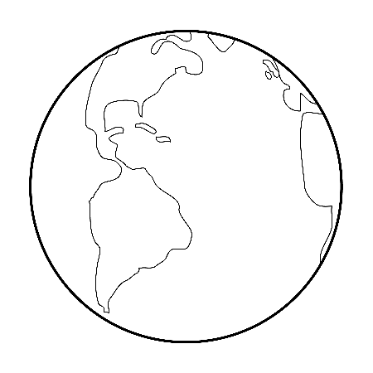

Your Body Name:

Colour two parts of your body blue. Colour one part of your

body red.

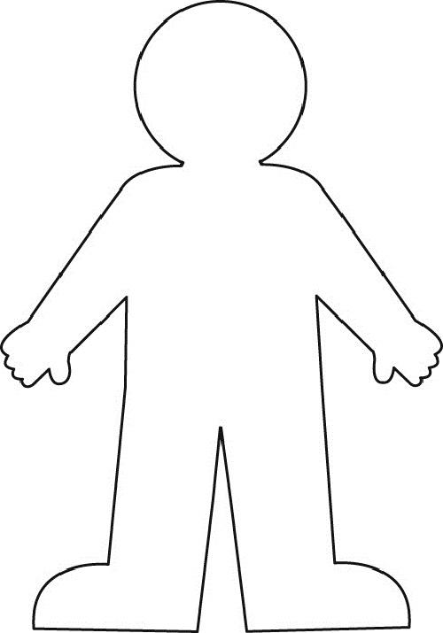





Question Time! Name:

Look at the picture of the Earth that you coloured.

All of the blue is water!

That is 3/4 of the Earth!

Circle the word that finishes the sentence:

The amount of water and the amount of land are equal/unequal.

Pick the correct statement:

Amount of Water = Amount of Land

Amount of Water ≠ Amount of Land

Look at the picture of your body that you coloured.

All of the blue is the water!

All of the red is EVERYTHING else in your body!

2/3 of your body is made of water!

Circle the word that finishes the sentence:

The amount of water and the amount of everything else in your body are equal/unequal.

Pick the correct statement:

Amount of Water = Amount of Everything Else

Amount of Water ≠ Amount of Everything Else

Bonus Question

Fill in the blank with either the equal symbol (=) or the unequal symbol (≠).

Amount of Water of Earth ___ Amount of Water in Your Body

**Hint** Take a look at the pictures you colored. Do they have an equal amount of blue?

**Fun with Jello!**

Today we learned about the states of matter with jello.

**First**, we ______________ water in a kettle. 

Water is a ______________ . When the __________ boiled. It turned into a __________.

__________ caused this change.



**Second**, we mixed the jello with the boiled _______.  The jello crystals were a _______. When they

mixed with the water, it turned into a _______.

**Last**, we put the jello into the fridge. It turned into a 

_______. __________ caused this change.

**Word Bank**

Liquid Water

  Boiled Solid

Gas Liquid

Steam Cold

Heat

|  |  |  |  |  |
| --- | --- | --- | --- | --- |
|  | 4 | 3 | 2 | 1 |
| Information |  |  |  |  |
| I could understand what the group was trying to say. |  |  |  |  |
| I could understand what their definition of water pollution was. |  |  |  |  |
| Presentation |  |  |  |  |
| The group used props, art, or pictures to enhance their video. |  |  |  |  |
| The groups spoke with clear voices. |  |  |  |  |
| The presentation was interesting to watch. |  |  |  |  |
| Team Work |  |  |  |  |
| Each person in the group said or did something during the presentation. |  |  |  |  |

Water Pollution Rubric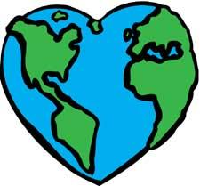

Group Names: __________________________

My Total: ____

Exploring Liquids using Math

Name: ___________________

1. Name 3 different kinds of liquids: _________________________________ , ___________________________________ and ________________________________ .
2. Circle the sentences that are TRUE about ALL liquids:
   1. Liquids can be poured.
   2. Liquids are wet.
   3. Liquids have no smell.
   4. Liquids take the shape of the container.
   5. Liquids are transparent.
3. We learned that the amount of land on Earth is equal/not equal to the amount of water on Earth. (circle one)
4. Draw a picture to represent what the term equal means.
5. Draw and write details on what happens to liquid water when…

|  |  |
| --- | --- |
| You leave it outside on a cold winter day. | You leave it in a cup by a sunny window. |
| You mix it with jello powder and stir. | When you put a droplet on a flat surface. |

1. Remember when we recorded data on different fluids? Put a circle around the liquid that flows the fastest. Put a line under the liquid the flows the slowest.

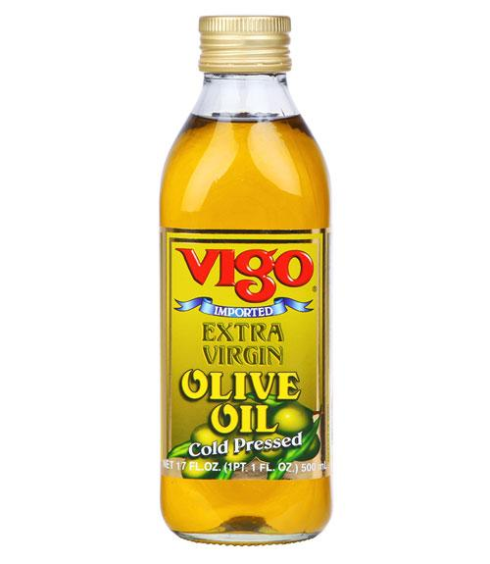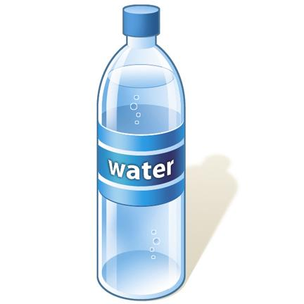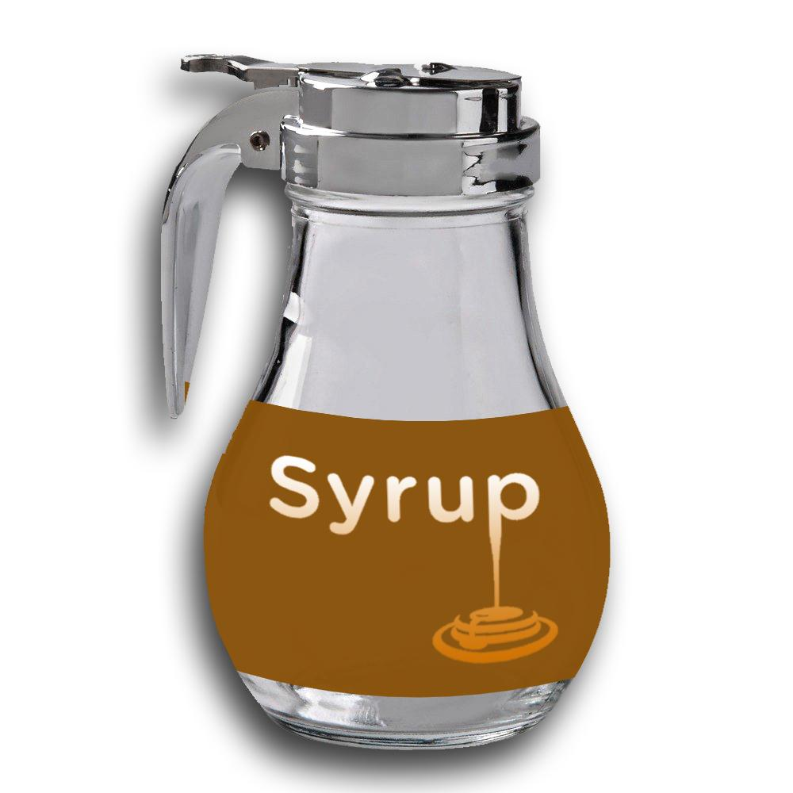

1. Mary spilled water on the floor. Name 2 materials that she could use to soak up the water. ____________________________ and ____________________________
2. A puddle can evaporate the quickest on what kind of day? __________________________________
3. Which container will we clearly see water evaporating from? (circle one)

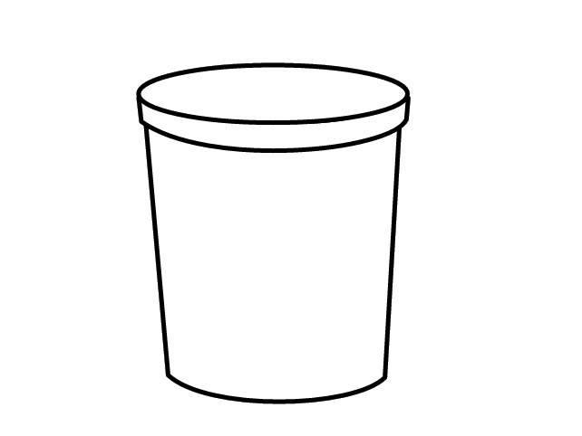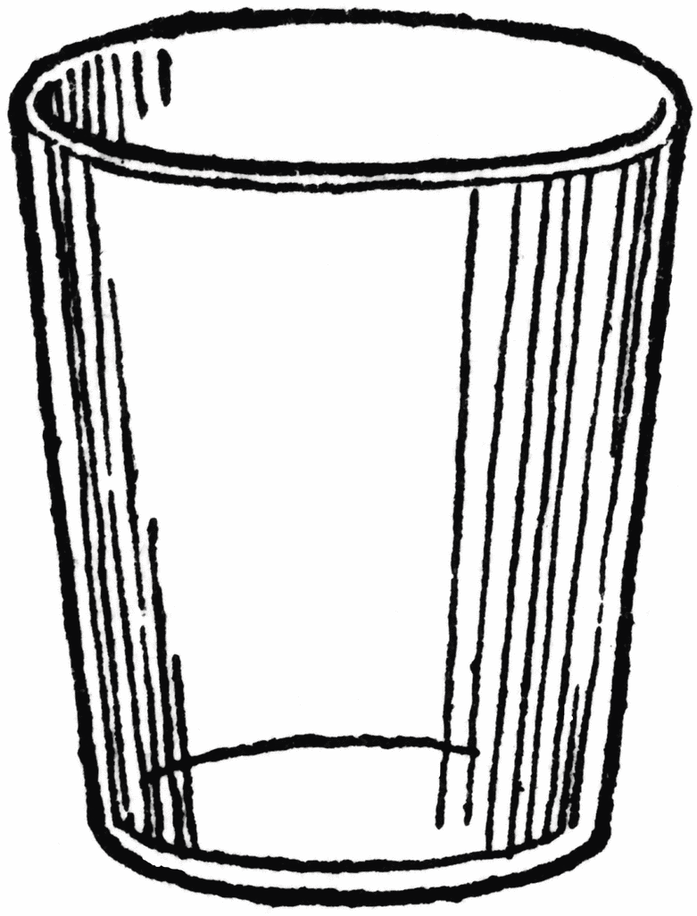

1. Name 2 things that will dissolve in water: ____________________________ and ___________________________.
2. The mathematical symbol for equal is _______________________. The mathematical symbol for not equal is ______________________.
3. Color in the fluid in the beaker so you have 7 lines.

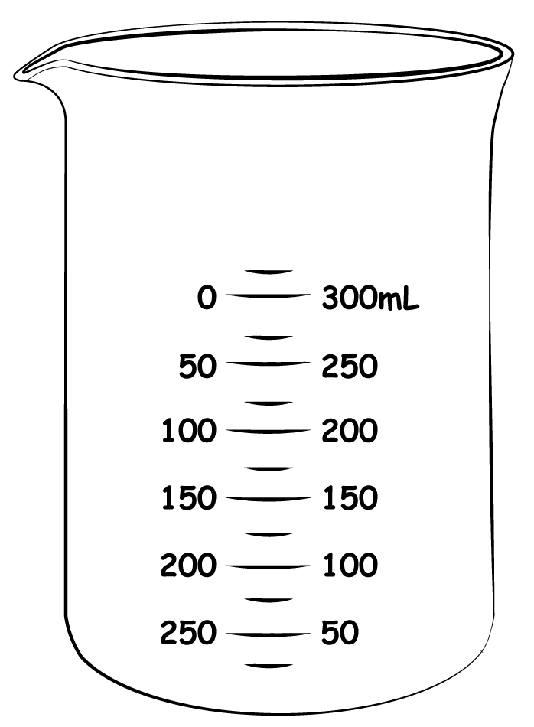

1. Name 2 things that will NOT dissolve in water: _____________________________ and ________________________
2. Draw a line from the word to the correct meaning:

Evaporation Solid to a Liquid

Freezing Gas to a Liquid

Absorbs Liquid to a Solid

Precipitation Soaks Through

Melting Liquid to a Gas

1. Use mental math to answer the following questions:

4 + 3 + 2 + 4 = _____

5 + 2 + 4 + 3 = _____

1. List 2 ways that people pollute Earth’s water: _____________________ and

_____________________